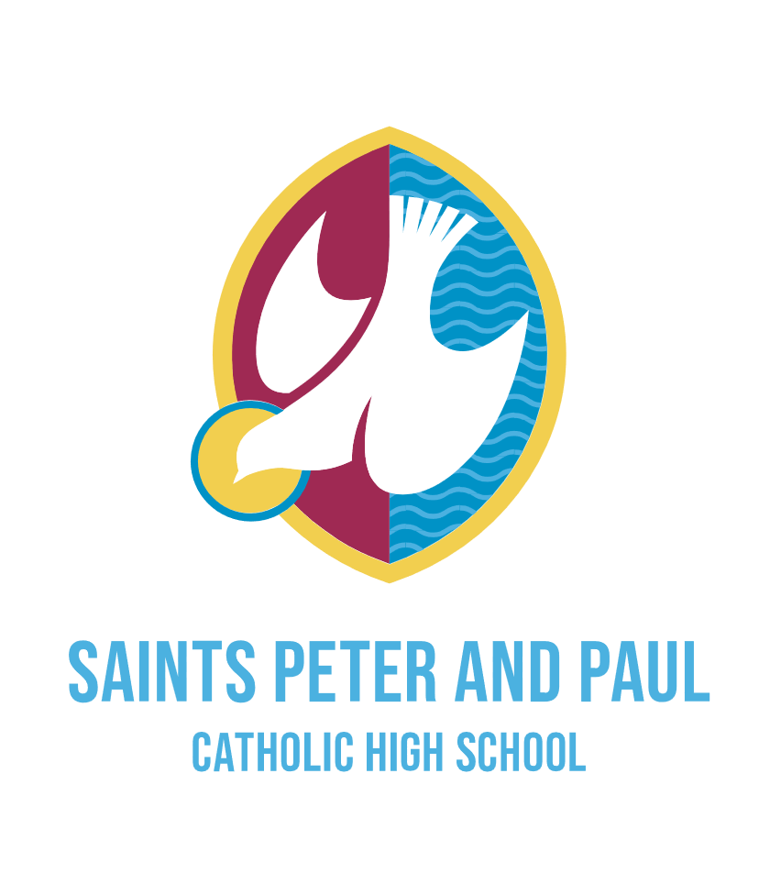
Job Advert

Executive Assistant

HBC 6 £32,061 - £34,434
(Pay award pending)

Full time | 37 hours per week
Saints Peter and Paul Catholic High School is a vibrant and successful school at the heart of the Widnes community. Rooted in strong Catholic values, we are committed to excellence in education and the holistic development of every student.
We are seeking to appoint an exceptional Executive Assistant to provide high-level support to our senior leadership team and Governors.
We are looking for someone who is:
- Highly organised with outstanding communication skills
- Discreet, professional and able to handle confidential matters with integrity
- Proactive, solutions-focused and able to work on their own initiative
- Able to manage competing priorities in a fast-paced environment
- Calm under pressure with a positive and engaging personality
The successful candidate will receive:

- A welcoming, supportive and values-driven school community
- A varied and rewarding role at the heart of school leadership
- Opportunities for professional development
- The chance to make a real impact on the day-to-day success of the school

Further information and an application form can be found on the school website: Saints Peter and Paul Catholic High School | Vacancies

Please send completed application forms to: recruitment@saintspeterandpaul.halton.sch.uk

Strictly no CVs. CES Application forms only with supporting statement.

Closing date for applications: 9am on Monday 7th September 2026

Saints Peter and Paul Catholic High School is committed to safeguarding and promoting the welfare of students and the post is subject to an enhanced DBS check and references.

