

Senior Sales Executive
Recruitment Pack
August 2026





Contents

 | Page
Welcome letter | 3
About Hexagon | 4
About the Development & Sales Team | 5
Job description | 6
Person specification  Our Cultural Matrix & Care Behaviours | 10  12
Organisation chart | 13
Principal terms and conditions of service | 14
The advertisement | 16
Key dates and selection process | 18

Welcome letter

18/08/2026

Dear Candidate

Senior Sales Executive

Thank you for your interest in working for Hexagon Housing Association.

If you require a copy of this document in an alternative format, please contact us on the details below.

As a provider of high-quality housing and care services, we believe it is important to recruit talented individuals who share our vision to be the provider of choice.

We know that attracting and keeping the best people is the most effective way to build a successful business, so we are committed to investing in you and your future, offering a competitive remuneration package and providing extensive learning and development opportunities throughout your career.

This pack gives background information on Hexagon and the role you are applying for. Please make sure your application reaches us by Sunday 6th September.

You will be contacted within ten working days of the closing date if you have been shortlisted. If we do not contact you, then please assume that you have been unsuccessful on this occasion.

Please note we do not accept CVs. Applicants must fully complete our online application form.

Good luck!

Hexagon Human Resources
Tel: 0208 768 7941
Email: recruitment@hexagon.org.uk
Web: www.hexagon.org.uk/careers

About Us
Hexagon Housing Association owns and manages approximately 4200 homes in south-east London and Kent. Most of our stock is general needs housing but our portfolio of shared ownership and leasehold housing is growing. We also have over 300 homes in Supported Housing schemes, about two thirds of which we manage ourselves and one third is managed by Supported Housing agencies. Co-operative managing agents manage about 300 of our general needs rented homes.

Our partner boroughs are Southwark, Lewisham, Greenwich, Bexley and Croydon, with a small number of homes in Bromley and Kent. We are building new homes for rent and shared ownership, currently mostly in Southwark, Croydon and Bexley. Our shared ownership and leasehold portfolio is expanding and is expected to continue to grow in the future.

Our homes include all types ranging from modern purpose-built blocks of flats, through to Victorian houses converted into flats and houses. We do not manage any large estates – our biggest single estate is 100 flats – but we do manage a number of small estates and blocks.

As an organisation, we are concerned with people, their homes and communities. We make good quality, affordable housing and services available to people in South London, and work to extend opportunities and improve the neighbourhoods they live in.

Like all housing associations, Hexagon is a not-for-profit organisation and is regulated by the Regulator of Social Housing (RSH).

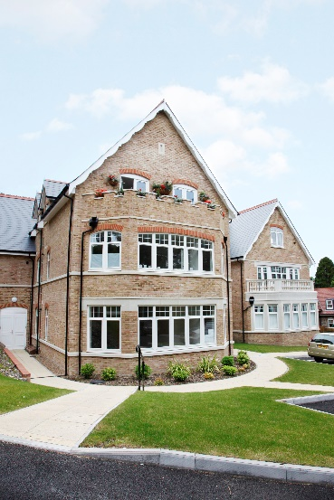
Hexagon currently employs 120 staff. We recognise the importance of making Hexagon a great place to work and are committed to continuously improving staff engagement. We are a certified Great Place to Work organisation with IIP Gold. All of our staff are based at our office in Sydenham SE26 and although the office will be your place of work, our expectation is that office and home working is blended to ensure that it works for both staff and the organisation.

Our values are designed to enable us to:-
Put our Customers at the heart of what we do
Appreciate difference
Be Responsible (and accountable)
Empower our people
The Team

We are Greater London Authority (GLA) Investment Partners developing new homes in the London boroughs of Southwark, Lewisham, Greenwich, Bexley and Croydon.

We are completing delivery over 120 new homes over the next few years, largely funded by the GLA Affordable Homes Programme and we are also seeking to deliver more homes through the purchase of S106 opportunities.

Approximately 75% of the current programme is shared ownership, with a few outright sales and the rest being London affordable rent or social rent.

Thus, over the next two years, we will be marketing and selling around 100 new homes. We also oversee the re-sale of existing homes, as well as staircasing transactions, lease extensions, and Right to Acquire transactions.

The Development and Sales team currently comprises 2 Project Managers, a Senior Sales Executive, a Sales Executive and an Administrator to progress the projects to completion and end of defects liability period. The team is currently being led by an Interim Development and Sales Director.

The Senior Sales Executive position has been vacant since the Spring and since then it has been covered by interim staff. We are now looking to recruit to the position permanently. This person will be a key team member and will be responsible for all Sales and Marketing activity for Hexagon. They will line manage the Sales Executive role and project manage various external consultants, including sales agents, solicitors, and marketing consultants.

We are looking for an experienced Senior Sales Executive who is proactive in hitting sales targets and passionate about providing good resident sales experiences. They must be knowledgeable on all current regulatory compliance, particularly for shared ownership sales, and they must be able to focus on optimising financial returns across the sales programme.

Job Description
Job title: Senior Sales Executive

Responsible to: Development, Sales and Major Projects Director

Purpose:

- Effectively market and sell Hexagon’s home ownership properties, maximising financial returns and ensuring prompt sales while in accordance with legislation, regulatory guidelines and Hexagon’s policies and procedures.
- Lead on providing an effective, responsive and customer-oriented sales service in relation to RTA, SHB, staircasing and resales, and lease extension transactions.
- Line manage the Sales Executive position
- Support the wider Development Team as required.

Principal Accountabilities:

New Sale / Resale Administration

- Drive the delivery of Hexagon’s Sales and Marketing Strategy, achieving the sales targets for shared ownership and outright sale properties.

- Oversee and Performance manage all new build sales activity for the organisation, ensuring all homes are sold, maximising sales prices within the agreed marketing period.

- Performance manage internal staff and external consultants as related to sales activity – overseeing external estate agents, on site sales teams, and mentoring junior staff.

- Lead, coach and develop junior staff, setting objectives, monitoring performance and supporting their professional development.

- Procure and manage sales agents and other relevant external consultants (marketing design teams, show home dressings, etc) in line with all relevant legislation and Hexagon procedures.

- Coordinate, oversee and guide buyers through the entire purchasing journey, coordinating with any required external parties, including financial institutions, solicitors, and surveyors.

- Maintain and develop an effective and efficient administration system that ensures customers receive a high level of assistance and advice throughout their purchase and achieve prompt completion of all legal matters.

- Liaise with relevant internal departments on service charge implications, maintenance schedules, lease plans, and specifications – ensuring all are available prior to launch and keeping colleagues up to date on impending sales.

- Organize and implement show home furnishings and designs, including sales offices where appropriate.

- Prepare and maintain sale price lists and provide regular and accurate sales reporting to Directors and Board as required.

- Organize property viewings to ensure homes are sold or let within agreed targets. Wherever possible, seek to achieve off plan sales.

- Negotiate sales prices and incentives with purchasers within prescribed parameters and conduct negotiations with purchasers, recommending purchasers and purchase prices to the Development and Sales Director.

- Instruct solicitors on sales to act on behalf of Hexagon, ensuring they are in receipt of all documentation required for the conveyancing process and sales progress to a quick exchange of contracts.

- Closely monitor the progress of sales and take action as necessary to ensure sales targets are achieved. Identify and resolve problems in an efficient, cost effective, and customer focused manner.

- Liaise closely with the Development Teams on building specifications, show home provision and proposed handover dates. Attending site meetings and handovers as required.

- Oversee and manage the sales completion process, ensuring purchasers move in is as efficiently as possible, including coordinating home demonstrations and handovers and issuing moving in packs, defect procedures etc.

- Appraise applications to ascertain eligibility.

- Manage the reservations procedure in accordance with the Allocations Policy. Monitor progress of purchases, setting, monitoring and enforcing deadlines.
- Administer the set up and progression of resale enquiries and conveyancing, providing an efficient and cost-effective service to the leaseholder.

- Arrange and conduct viewings in accordance with agreed procedure. Evening and weekend work will be required for viewings and exhibitions.
- Liaise and collaborate with all relevant internal and external stakeholders, including finance, development, housing management, departments.

- Stay up to date on all relevant legislation affecting the sales of new build properties and ensure that Hexagon’s policies and procedures are fully compliant.

Marketing

- Lead on all sales marketing activity for Hexagon – managing internal staff and external consultants as required.

- Produce and enforce scheme marketing plans that focus on achieving off plan sales.

- Prepare development launch strategies and manage digital marketing campaigns – overseeing the production and distribution of marketing material, mailshots etc and ensuring all material complies with relevant legislation and Hexagon policies.

- Coordinate and oversee each project’s marketing budget, ensuring that money is spent wisely and in an efficient manner.

- Undertake marketing and comparable sales research on specific schemes to determining the marketability of the scheme – analysing lead generation and conversion performance.

Staircasing / Right to Acquire / Social Homebuy / Lease Extensions / Remortgaging

- Following procedures, administer transactions in accordance with Hexagon’s policy.

- Liaise with tenants, solicitors and mortgage lenders and internal colleagues etc to ensure an expedient process, managing any issues as they arise.

- Liaise with tenants, solicitors and mortgage lenders and internal colleagues etc to ensure an expedient process, managing any issues as they arise.

- Submit documentation to Head of Development /Development & Sales Director to enable timely grant claim submission.

General
- Represent Hexagon at external meetings as required.
- Act always in accordance with Hexagon’s published policies and procedures.
- Maintain high standards of probity and confidentiality.
- Take responsibility for self-development, attending training, supervision, appraisals, team meetings and staff conferences as required.
- Carry out all other duties as may be reasonably be assigned.
Notes
- All tasks within this job description may be carried out on behalf of Hexagon Housing Association Ltd, it subsidiaries and any associated organisations.
- Post holders will always be consulted before job descriptions are amended.

Person Specification –
Senior Sales Executive

Skills Required | Level
Work Experience | Essential  - Proven background in residential sales or lettings, gained in a housing association, estate agency, house builder or comparable sales and marketing environment.  - Experience managing and motivating a high performing sales team and the performance of external sales agents and consultants  - Experience in implementing efficient and effective sales and marketing processes.  Desirable  - Experience in processing Right to Acquire, resales and/or staircasing applications for a housing association or similar organisation
Skills/Knowledge/  Abilities | Essential  - Experience of marketing and selling shared ownership sales.  - Excellent knowledge of maximising sales values, achieving sales targets and off-plan sales  - Sound knowledge of the property conveyance process  - Understanding of relevant legislation and Regulations (i.e. Landlord and Tenant/Leaseholder responsibilities, The Consumer Protection from Unfair Trading Regulations and the Business Protection from Misleading Advertising Regulations)  - Excellent negotiation and customer service skills to deal with diverse buyers and stakeholders  - Excellent verbal and written communications skills, including ability to produce marketing material in plain English  - Strong IT and numeracy skills, (Word, Excel and databases)  - Methodical and well organised with good attention to detail and ability to maintain accurate comprehensive records  - Ability to adhere to set procedures and regulatory deadlines  Desirable  - Ability to use sales CRM systems – ideally knowledge of both KPro and CX
Personal Qualities | Essential  - An effective leader who can foster effective collaboration between internal and external teams  - A personal “can do” attitude with a commitment to providing excellent customer service.  - High level of drive and determination.  - Able to work weekends and evenings as required.  Desirable  - Full UK driving licence and has access to a car for work

You will only be short-listed from the details written on the application form if you meet all of the criteria ranked as Essential.

Our Culture Web and CARE Behaviours

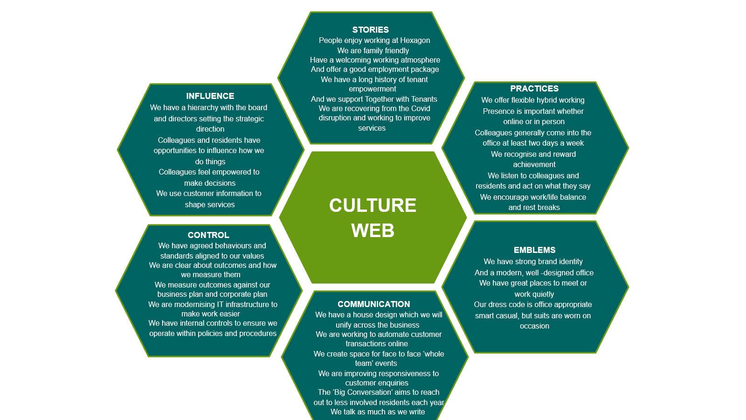

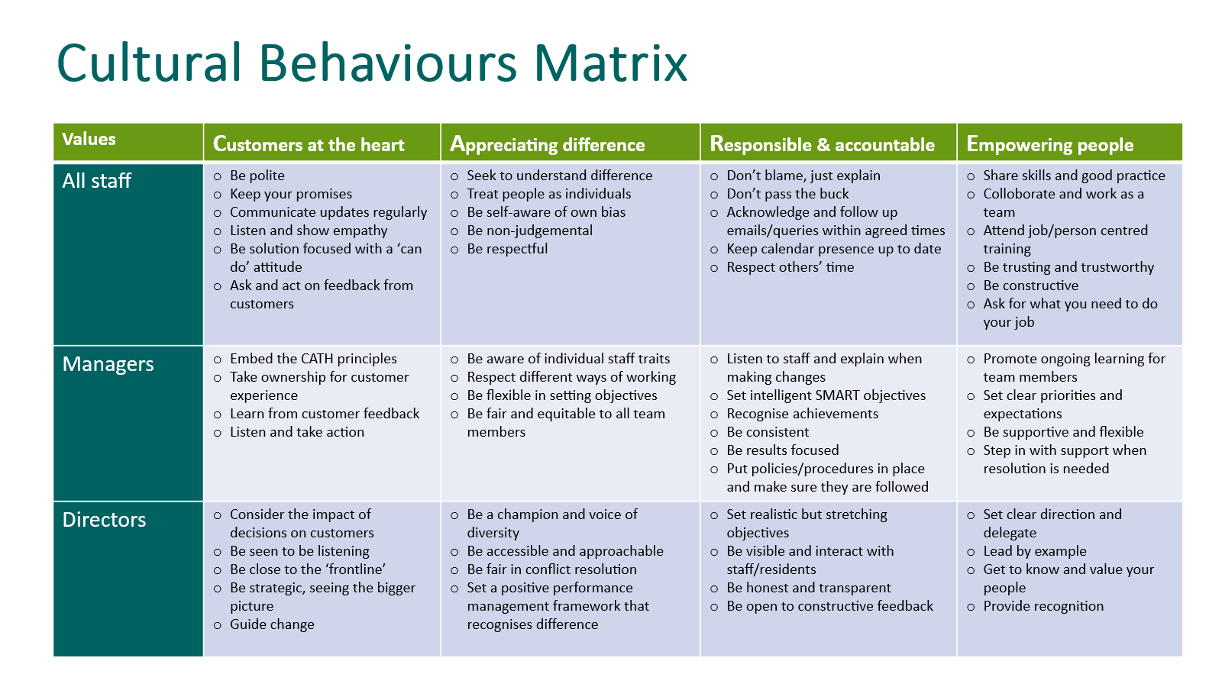

Organisation Chart

?

?

Principal terms and conditions
(For information purposes only)

Working for Hexagon

We pride ourselves on providing a working environment which allows people to enjoy what they do, develop their skills and fulfil their potential. We are accredited by Investors in People with Gold status, demonstrating our commitment to the development of our staff. We offer excellent conditions of employment, and training programmes.

1. Position

Senior Sales Executive

2. Remuneration

£48,314

3. Our generous range of benefits includes:

Core Benefits
- Defined Contribution Pension scheme.
- Career break scheme.
- Excellent Employee Assistance Programme (EAP)

Work life balance
- Hybrid Working/TOIL.
- Maternity, paternity & shared parental leave.
- Adoption Leave.
- Carers Leave.

Other Benefits
- Salary Sacrifice – Gym Membership Scheme.
- Salary Sacrifice – Car Leasing Scheme.
- Salary Sacrifice – Computer Scheme
- Season Ticket Loan
- Cycle 2 Work Scheme
- Private Medical Insurance

Rewarding our staff
- A comprehensive corporate training and development plan.
- Fully comprehensive induction and training for all employees.
- Staff Excellence Awards.
- Social Events.

4. Annual Leave

26 days plus 8 public holidays increasing by 1 day per annum up to 31 days.

5. Location

Your normal place of work will be our head office at 130-136 Sydenham Road
Sydenham, London SE26 5JY. Arrangements for Hybrid Working (minimum 2 days per week office) will be discussed with the successful candidate.

6. Working hours

Full time – 35 hours per week

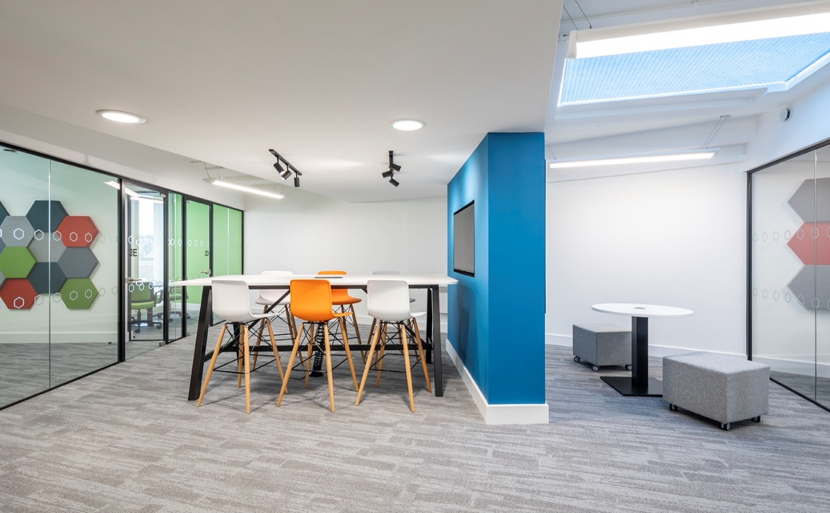

A workspace at our Sydenham Road Office

The Advertisement

Senior Sales Executive
£48,314
Full-time – 35 hours per week
South East London (Hybrid Working)

Hexagon is an innovative and responsive housing association working in partnership with a range of local authorities to meet housing needs across Southeast London. With a turnover of £40m, 120 staff and over 4,000 homes, Hexagon is continually improving the quality and range of our affordable homes and services.

As an organisation we are concerned with people, their homes, and communities. We make good quality, affordable housing, and services available to people in the local areas we serve, and work to extend opportunities and improve the neighbourhoods they live in.

Are you ready to make a tangible difference in South East London? We are delivering circa 200 new homes over the next two years, largely funded by the GLA Affordable Homes Programme(2016-21). Roughly 60% of this programme is shared ownership alongside London affordable rent, social rent and a small number of outright sale homes.

Based in our Development and Sales Team, you will report directly to the Development, Sales & Major Projects Director and line manage a Sales Executive. You will drive the marketing and sale of home ownership properties, maximise financial returns and ensure prompt sales in accordance with legislation, regulatory guidelines and Hexagon’s policies and procedures. You will also lead on providing an effective, responsive and customer-oriented sales service in relation to RTA, SHB, staircasing and resales, and lease extension transactions.

With a proven track record in residential sales or lettings, gained within a housing association, estate agency, house builder or comparable sales and marketing environment. Our ideal candidate will also have the following experience:

- Managing a high performing sales team and the performance of external sales agents and consultants.
- Marketing and selling shared ownership sales.
- Maximising sales values, achieving sales targets and off-plan sales
- Sound knowledge of the property conveyance process.
- Experience in implementing efficient and effective sales and marketing processes.

Experience in processing Right to Acquire, resales and/or staircasing applications for a housing association or similar organisation is desirable but not essential.

This role presents a brilliant opportunity to further your career with a dynamic Great Place to Work accredited company with IIP Gold, that is committed to employee engagement, values its staff and provides a work environment that is built on flexibility, empowerment, and a commitment to support you to be the best that you possibly can. If you want to work with a fantastic team and feel proud of the contribution that you make each day, then we very much want to hear from you.

We will offer you training and supervision to help you achieve your full potential, and an excellent package including private medical insurance, pension scheme with 3 x salary life assurance, flexible hybrid working (minimum expectation is 2 days per week office based), and 26 days annual leave rising one day per year to 31 days.

To apply, please send your CV and supporting statement in Word format to recruitment@hexagon.org.uk. No agencies

Closing Date: Sunday 6th September 2026
Interviews will be held in person on Thursday 17th September 2026

We are committed to building a diverse workforce and making Hexagon an inclusive place to work where everyone can be themselves and feel valued for their contribution.

Accessibility and Adjustments
We are committed to providing reasonable adjustments throughout the recruitment process to ensure inclusivity. If you have any specific requirements, please contact recruitment@hexagon.org.uk

Key dates and the selection process

Closing date: | Please make sure your application is submitted by Sunday 6th September
Shortlisting: | Wednesday 9th September
Interviews: | Will be held face-to-face at our offices in Sydenham SE26 on Thursday 17th September 2026.  With panel members:  Interim Development & Sales Director  Senior HR & Facilities Officer

