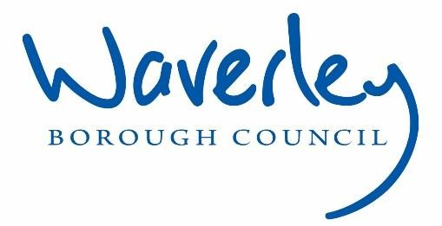

Waverley is an ambitious authority, committed to being one of the leading Councils in the country at a time of major change by developing a high performing, highly engaged staff team to share the organisation’s values and deliver our corporate objectives.

JOB DESCRIPTION
Job title: | Mechanical & Electrical Compliance Manager
Service: | Housing Operations
Team: | Compliance Team
Location:  Reporting to: | The Burys, Godalming, Surrey, GU7 1HR  Regulatory Compliance Manager
OUR ORGANISATIONAL VALUES
Collaboration | We know, work with and support one another.  In Waverley & Guildford we collaborate with residents, business & partners, to realise the potential of collaborating.  We empower ourselves and others.
Wellbeing | We look after our own and other’s wellbeing.  In Waverley & Guildford we know it’s okay to talk to each other about anything we are struggling with.  We stay resilient and raise any concerns we have.
Trusted | We abide by the Nolan Principles of Public Life.  Selflessness, Integrity, Objectivity, Accountability, Openness, Honesty, Leadership
Value For Money | We spend public money wisely and carefully.  We understand and follow our governance process and raise and concerns with the right person.  We celebrate successes and learn from mistakes.
Professionalism | We provide professional advice and excellent service; we know our local areas and understand the communities we serve.  We listen to all concerns and ideas. We benchmark our performance and strive to improve.
PRINCIPAL PURPOSE OF THE ROLE
- The overall purpose of the job role is to lead and manage the Mechanical & Electrical capital works including commercial pant rooms and electrical compliance within Housing Operations, managing the associated contractors or consultants to ensure adherence to all Health and Safety legislation to ensure all areas under the housing portfolio are maintained and have none or minimal risks associated with them. To lead on contract management of all designated contracts and procurement of contracts when applicable.

- Responsible for managing the Heating and Electrical contracts in terms of capital programme, cyclical maintenance and any other safety requirements, as part of the contract.
- To assist with the strategy for the longer longer-term replacement strategy, working with the Asset Team and Energy Efficiency Project Support in the priorities of having our homes achieving net carbon zero in the Borough by 2030.
- Work closely and in co-ordination with the Regulatory Compliance Manager with regards to contracts, programmed works and any other high-priority business critical need identified.
- Create, implement, review & maintain the replacement strategy for all properties with electrical storage heaters.
- As part of the wider Housing Department, you will need to support the Regulatory Compliance Manager and
Strategic Asset Manager to deliver in the success of our repairs and maintenance service, creating excellent partnerships, leading a knowledgeable and customer focused team, working alongside colleagues across the Housing Operations service.
MAIN DUTIES AND ACCOUNTABILITIES
Operational Duties
- Manage the delivery of domestic gas boiler replacement programme, plant room servicing and replacement programme.
- Manage the delivery of the domestic and commercial gas procurement contract tender to award in line with the Council’s Contract Procurement Regulations.
- Lead a small number of plant room works for the Senior Living Schemes and communal properties
- Maintain the delivery of the electrical planned cyclical programme including major upgrades or whole installation re-wiring programmes.
- Maintain the delivery of the non-domestic lift servicing and replacement programme
- Maintain the delivery of the planned cyclical servicing programmes including major upgrades for domestic properties.
- Manage the replacement & maintenance programme of properties with electrical storage heating systems
Assist with the Asset Teams Thermal comfort upgrade works in relation to heating requirements. Once accessories are installed, such as air source heat pumps, these items will become part of your servicing programme.
- Work in close co-ordination with the Regulatory Compliance Manager to ensure compliance policies and procedures are regularly reviewed ensuring adherence with current regulations and legislation, before the anniversary dates expires.
- Provide technical advice and support to Housing Operations colleagues to advise on the feasibility of M&E capital improvement works including Air Source Heat Pumps and other alternative heating technologies.
- Challenge poor performance and develop remedial action plans to safeguard the Council and its residents where performance is failing, escalating issues and concerns to appropriate stakeholders
- Produce regular performance management reports to Management Board and Members
- Ensure that all Compliance records are fed into the asset management system are updated ensuring data integrity.
- Provide data and information to support the annual return of Tenant Satisfaction Measures for the Regulator of Social Housing

Contract Management
- Lead on all contract management duties including monitoring budgets against spend, performance management, contract delivery and progression to ensure best value for money and quality works.
- Chair or assist in leading operational and strategic group meetings for all relevant compliance owned contracts.
- Monitor contractual terms and conditions for Compliance contracts and projects, working with contractors to resolve issues or escalating as necessary.
- Provide subject matter lead on legislation, ensuring updates or changes are reflected in the Council’s policies and procedures in a timely manner.

Team Work and Communication
- Develop robust and effective stakeholder and supplier relationships, working closely with contractors to develop partnering arrangements.
- Promote collaborative and cross functional team working to meet operational targets and priorities.
- To assist the Section 20 process of leaseholder management is adhered to and ensuring leaseholder communication completed.
- Provide expertise advice and support to officers and managers across the Council on matters relating to Compliance.

Training and Development
- Identify and undertake training and development opportunities as required to ensure the available skills are in place to meet the business objectives, and to enable the achievement of potential
- Ensure that the wider Housing Department is appropriately trained in key compliance policies and activities to ensure adherence to Council’s policies, regulations and legislation.

Finance and Budgets
- Efficiently and effectively assist monitoring and manage budgets for the -M&E Capital work & Revenue allocations.
- Contribute to your service area business plan to include priority projects, financial forecasts and expenditure review, providing regular updates to Head of Service.
- Manage and advise on M&E Capital programmes, ensuring the Council meet Health and Safety obligations, whilst ensuring that programmes remain within budget.
- Authorise invoice payments up to the delegated authority threshold of the post holder.

Customer Service
- Corporate – Deliver excellent service to customers in line with published service standards
- Equality & Diversity – Actively promote the Council’s Equality and Diversity policy in all aspects of your duties.
- Safeguarding – Ensuring adherence for both Officers and Contractors to effective safeguarding practices for vulnerable adults and children in accordance with the Council’s policies, guidance and protocol.
- Dignity and Respect – Treat all colleagues with dignity and respect whilst at work so that they can be encouraged to meet their full potential working in a non-threatening environment free of harassment and/or bullying.
- Data Protection (GDPR) – Ensure that the principle of confidentially and the requirements of the Data Protection Act (and future GDPR requirements) are fully applied to the work of your service area.
- Information Sharing – Work in line with the relevant protocols and service level agreements to enable the effective sharing of information between agencies.

Service Development and Improvement
- Lead on service development and improvement initiatives, to provide innovative solutions to improve service and process delivery within Compliance Team.
- Manage and investigate complaints in line with Councils policy, Ombudsman recommendations, sharing and embedding learnings to aid service improvement.
- Research opportunities in implement new building maintenance techniques, products or materials making recommendations of suitability to enhance and develop working practices within Property Services.

Business Continuity
- Play a pivotal role in business continuity planning and should the need arise assist in ensuring business recovery of key service provision in a 24-hour window.

Health and Safety
- Comply with all Health and Safety legislation for your area of work, ensuring that plans are prepared and adhere to and risks are identified, managed and monitored as required.
- Understand the client and contractor roles under the Construction (Design and Management) Regulations 2015.
- Understand the Control of Asbestos Regulations 2012
- Be competent in the understanding of the relevant Gas and Electrical regulations and compliance areas
- Understand Building Regulation and its involvement in any M&E associated works.
- Understand Fire Safety Regulations and its impact in any M&E associated works
DIMENSIONS OF THE ROLE
- Budget Responsibility - approximately circa £4M per year

AREAS OF ACCOUNTABILITY

- Responsibility for adherence of compliance within plant rooms, domestic heating and major upgrades, across the Council housing stock,
- Ownership of all relevant Housing Health and Safety policies, procedures and management plans, to ensure that they are current, regularly reviewed and meet the required guidance, regulation and legislation.
- Responsibility for the contract procurement for Domestic gas servicing and replacements to the value of circa £2 million in line with Contract Procurement Regulations and Financial Regulations, until 2028.
- Contract management duties including budget monitoring, performance management, contract delivery and progression to ensure value for money
- Provide line manager support guidance to relevant officers and to ensure that all members of the Compliance team have the Skills, Knowledge, Experiences & Behaviours to continue to be focused on building a continuous professional development culture.
- Produce regular performance management reports to Corporate Management
Board, Landlord Services Advisory Board, H&S Committee, Overview and
Scrutiny Committees and for Tenant Satisfaction Measures for the Regulator of Social Housing
PLANNING/ORGANISING/CONTROLLING/ PROBLEM SOLVING/ DECISION MAKING / SCOPE FOR IMPACT
- Ownership of all Level 1 complaints for maintenance, new installations & commercial heating and any electrical or lifting equipment complaints.
- Work in conjunction with the Compliance Team to ensure compliance on heating and electrical upgrades in line with statutory requirements.
- Dealing with underperforming contracts including health and safety breaches
- Resolving contractual disputes and gathering evidence in cases for escalation
- Supporting and supervising staff including taking capability and disciplinary action
- Research, draft and review key strategic policies and procedures.
- Identify areas within the Compliance service for business improvement
- Chairing or assisting contract meetings, ensuring agreed outcomes are achieved
- Approving payments up to the value of the delegated authority for the post holder
- Approving actions outside of the Council’s policies for the service area
CUSTOMERS AND CONTACTS
INTERNAL
- All staff including Management Board,
- Executive Members including the portfolio holder for Housing Services
- Ward Members
EXTERNAL
- Contractors, suppliers, service providers, tenant and resident groups, partnering agencies, leaseholders and members of the public.

SERVICE/TEAM STRUCTURE
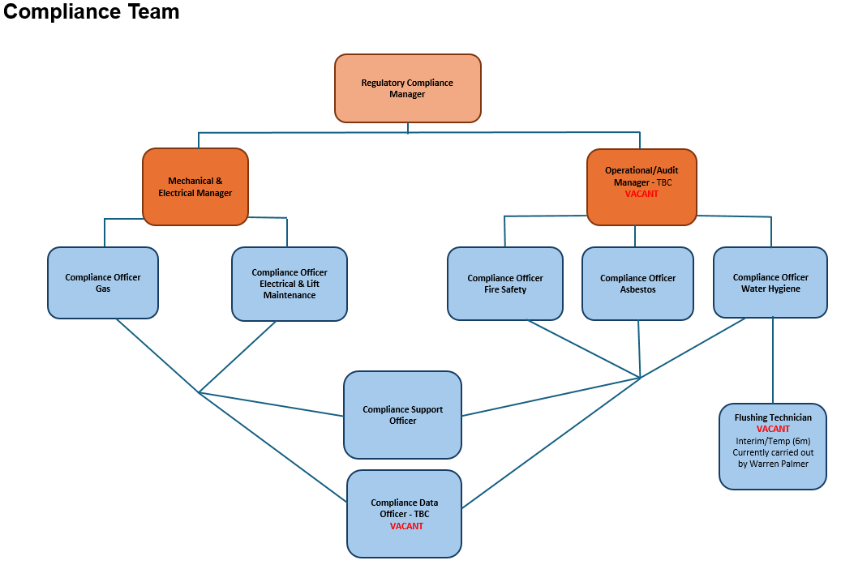

PERSON SPECIFICATION

Candidates must be able to demonstrate, giving examples, all essential criteria marked as A, A/C, A/I/E or A/I within their application form to be shortlisted for this role.

The applicant must meet all of the essential criteria to meet the entry level requirements, and the desirable criteria to achieve the final level.
 | PERSON SPECIFICATION
 | ESSENTIAL CRITERIA | HOW  ASSESSED | DESIRABLE CRITERIA | HOW  ASSESSE  D
QUALIFICATIONS  / EDUCATION /  TRAINING /  EXPERIENCE | Demonstrate a higher degree of knowledge of the NICEIC 18th Editions and the Gas Safety (installation and Use) Regulations | A/I | Evidence of a social housing background and/or in-depth understanding of the Gas and Electrical regulations | C
QUALIFICATIONS  / EDUCATION /  TRAINING /  EXPERIENCE | Holder of Degree, HND or equivalent and or  discipline qualified to  RICS or CIOB standard  or qualified by experience | A/C | Member of recognised professional body – or working towards membership | C
 | Demonstrate a higher degree of knowledge in  Mechanical & Electrical Compliance fields | A/I | Previously completed Certificate in IOSH /  NEBOSH | A/I
 | A willingness to commit to and undergo the agreed training programme and record for 20 hours CPD per annum. | A/I | Experience in staff management and development
KNOWLEDGE  /TECHNICAL  SKILLS | Experience of planning  and control of programmes of works to ensure works completed are of quality and provide value for money | A/I | Experience of public sector procurement
 | Experience Of Contract management and  contract administration to ensure service  delivery | A/I | Knowledge of section 20 process leaseholder consultation. | A/I

 | A technical awareness understanding of compliance areas (including health and safety) knowledge of legislative requirements  , regulations including  Gas Installation and Use Regulations 1998 and Landlords electrical safety certificate legal requirements and best practice within the sector | A/I | Awareness of Safeguarding | A/I
 | Understanding and knowledge of Building Safety Act 2022 | A/I | Knowledge &  understanding of TCW Software
 | A knowledge of a range of forms of contract including Term Partnering, Joint  Contracts Tribunal  (Minor Works,  Measured Term) and  Framework  Agreements | A/I
 | Budgetary  management experience and cost control. | A/I
 | Well-developed IT skills with knowledge of Microsoft Office at intermediate level. | A/I | .
COMMUNICATION | Demonstrates a wide  range of communication methods most effective for the situation and individual needs. | A/I | Ability to negotiate with  others to reach mutually beneficial outcomes, and can evidence successful outcomes | A/I
 | Experience of producing reports in a variety of formats to be presented at operational, corporate or strategic levels. | A/I | Experience of working  alongside Council  Members | A/I
 | Understanding of and commitment to promoting equality and diversity in service delivery and employment. | A/I | Experience of managing complaints | A/I

CUSTOMER  SERVICE | Demonstrate the ability to obtain and analysis customer feedback to facilitate an ethos of continuous service improvement | A/I
TEAM WORKING | Demonstrate effective team working through the successful delivery of projects and goals | A/I | Experienced at utilizing resources to ensure that service is delivered in efficient and effective ways to meet goals and targets. | A/I
TEAM WORKING | Ability to champion change and motivate staff and colleagues to actively contribute to improvements | A/I | Ability to take control of situations, providing the communication and assurance that decisions made are considered, risk assessed and are in the Councils best interests | A/I
TEAM WORKING | Ability to build constructive and productive internal and external relationships | A/I
MANAGING SELF  AND OTHERS | Provides clarity about requirements and accountabilities and  effective action if performance does not meet expectations | A/I
MANAGING SELF  AND OTHERS | Evidence of flexibility adaptability and responsiveness to changing needs and circumstances | A/I
MANAGING SELF  AND OTHERS | For business continuity purposes you are required to have access to the internet at home via broadband on a PC, laptop or tablet. | A
 | Demonstrate the ability to be understanding and honest with colleagues inside and outside your team. | A/I | Experience of managing staff | A/I
CAN DO  APPROACH / ACHIEVING  RESULTS | Takes personal responsibility and ownership for decisions, actions and consequences and learns from experience | A/I

ADDITIONAL  SPECIFIC  REQUIREMEN  TS FOR THIS  POST | Full and valid driving license and use of a car during working hours | A/I
 | Occasional attendance to meetings outside normal working hours | A/I

How assessed
A = Application CV/Personal Statement
- = Certificates/professional Registration
- = DBS police check
- = Exercise
I = Interview
M = Medical assessment

For Official Use only
Job title: | Mechanical & Electrical Compliance Manager | Post no:
Service: | Housing Operations | JE score:
Team: | Property Services | Pay band: | 4
Location: | The Burys  Godalming,  Surrey GU7 1HR | Position type:  (if part time, working pattern) | Full time  37 Hours/ Five day week
Competencies:  (level 1 – 4) | Communication: | 3
Competencies:  (level 1 – 4) | Customer Service: | 3
Competencies:  (level 1 – 4) | Team Working: | 3
Competencies:  (level 1 – 4) | Managing Self and Others: | 3
Competencies:  (level 1 – 4) | Can do approach/Results | 3
REVIEWED BY: | Paul Cleaver | DATE: | August 2026
CHECKED IN: | Human Resources this…? | DATE:
LAST UPDATED: |  | DATE:
11| P a g e

