

Waverley is an ambitious authority, committed to being one of the leading Councils in the country at a time of major change by developing a high performing, highly engaged staff team to share the organisation’s values and deliver our corporate objectives.

Job Description
Job title: | Planning Policy Technician
Service: | Planning
Team: | Planning Policy, Infrastructure and Planning Specialists (PPIPS)
Location: | The Burys, Godalming, Surrey, GU7 1HR
Reporting to: | Planning Policy Team Leader
Responsible for: | N/A
Our Organisational Values
Collaboration   | We know, work with and support one another. We collaborate with residents, businesses and partners and realise the potential of the Guildford and Waverley Collaboration. We empower ourselves and others.
  Wellbeing | We look after our own and other’s wellbeing. We know it’s okay to talk to each other about anything we are struggling with. We stay resilient and raise any concerns we have.
Trusted   | We abide by the Nolan Principles of Public Life: Selflessness, Integrity, Objectivity, Accountability, Openness, Honesty, and Leadership.
Value for Money   | We spend public money wisely and carefully. We understand and follow our governance processes and raise any concerns with the right person. We celebrate successes and learn from mistakes.
Professionalism   | We provide professional advice and excellent service, we know our local areas and understand the communities we serve. We listen to all concerns and ideas. We benchmark our performance and always strive to improve.
Principal purpose of the role
- To provide administrative, digital and technical support for the Planning Policy Team.
- To utilise appropriate datasets, maps and other information systems, including utilising GIS systems (QGIS), and providing accurate and up to date information necessary for the planning policy functions of Waverley Borough Council
- To act as the first port of call for queries for the Council’s planning policy function from all its customers including businesses, developers, other council officers, Council Members and the general public and appropriately triage
- To assist in the provision of an efficient, effective and professional Local Planning Authority service.

Main duties and accountabilities
- To collate, maintain, monitor and update relevant planning data and information.
- To triage all routine and technical enquiries, and requests for information from businesses, developers, council officers, towns and parish councils, borough councillors and the general public to the Planning Policy team and respond where appropriate or disseminate to planning officers.
- To provide digital, technical and administrative support for Planning Policy Team, including the use of relevant IT and mapping systems (including QGIS)
- To support members of the team in maintaining and analysing GIS datasets, creating digital maps to inform local plan evidence, policy development and monitoring outputs.
- To maintain and update relevant monitoring systems, including contributing to the preparation of the annual Authority’s Monitoring Report.
- To lead on administrative work, including arranging meetings and events, and supporting the delivery of specific projects, including gathering evidence and assisting in consultations on policy documents and the effective management of information/data.
- To provide technical and administrative support to other teams within the Council’s Planning Services, when appropriate.
- To administrate planning policy consultations from other bodies for the Planning Policy Team
- Health and Safety; to comply with all Health and safety legislation for your area of work, ensuring that risks are identified, managed and monitored as required

Dimensions of the role
- Agile Working. Attendance in the office, based in the Council Offices at Godalming, dependent on the current operational needs of the Service.
- To contribute to the preparation and delivery of the Local Plan within established deadlines.
- Assist communities in the preparation and making of neighbourhood plans.
- To assist the annual publication of the Authority Monitoring Report, Brownfield and Custom and Self-Build Registers and the publication of other planning policy and monitoring documents as necessary.
- To help collate, analyse and interrogate statistical data including housing, environmental, commercial and retail planning data
- Establishing, managing and maintaining various information/databases collection and storage systems
- Undertaking and assisting surveys, supporting the maintenance and use of GIS datasets and systems, preparing digital plans/maps
- Written and verbal enquiries received on all planning policy matters.

Areas of Accountability/Problem Solving – Decision Making / Scope for Impact
- Gathering and checking information and giving advice with guidance from other officers.
- Establishing and maintaining up-to-date and accurate information/data and the subsequent monitoring of it.

Planning/Organising/Controlling
- Providing accurate information to a range of customers, both internal and external.
- The ability to work accurately and be self-motivated.
- To plan and prioritise workload to ensure in-house and external timescales are always met.
- The ability to judge where it is appropriate to work on your own initiative and where decisions must be referred upwards.
- The ability to act with diplomacy and discretion when dealing with sensitive issues.
- The ability to adopt changes in working practices thus demonstrating adaptability and flexibility.
- Achieving performance indicators in ensuring the Planning Service achieves its targets

Customers and Contacts
Internal
- All Planning Service staff, all other Council services, Council Members
External
Town and Parish Councils, Surrey County Council, other local authorities, other organisations, the development industry, business organisations, amenity and special interest groups, Government Departments, regional organisations, members of the public, amenity and special interest groups.

Service/Team Structure
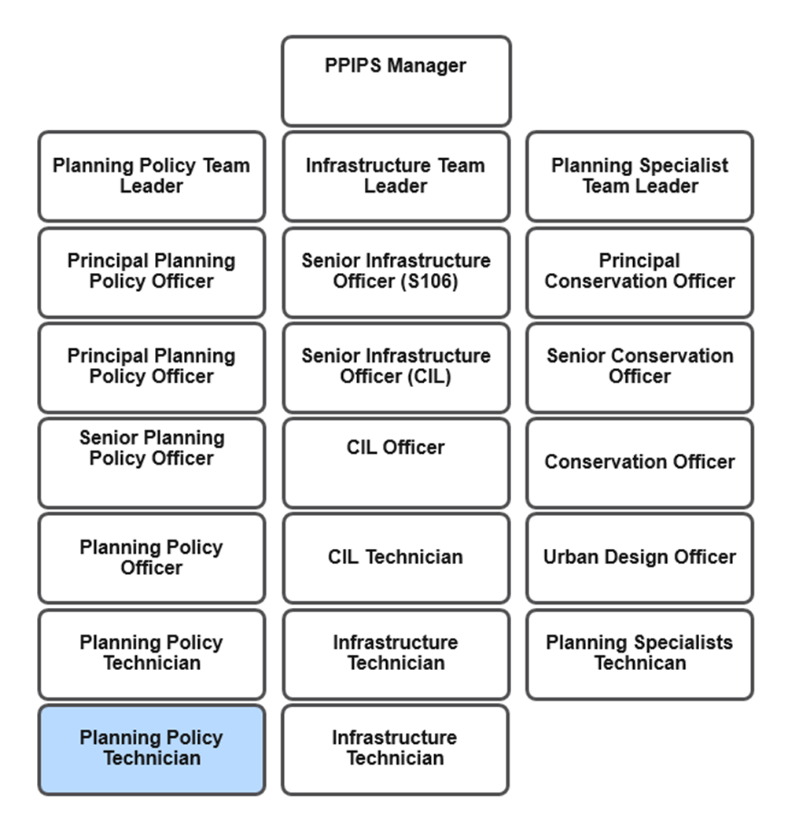

PERSON SPECIFICATION

Candidates must be able to demonstrate, giving examples, all essential criteria marked as A, A/C or A/I within their application form to be shortlisted for this role.

 | Person Specification
 | Essential criteria | How Assessed | Desirable criteria | How Assessed
Qualifications/ Education/ Training/ Experience | GCSE (or equivalent) level education. | A/C | General clerical/admin experience.  Experience in using GIS software (such as QGIS) in a work or educational setting. | A/I
Knowledge /Technical Skills | Competency in using IT systems including Word, databases, spreadsheets and mapping software. | A/I/E | Experience in using Word, mapping and spreadsheet software in a work environment. | A/I
Knowledge /Technical Skills | Ability to understand and read statistical information and plans. | - A/I/E | An interest in planning and the environment. | A/I
Knowledge /Technical Skills |  |  | Knowledge of or interest in GIS data and its application in planning policy.
Knowledge /Technical Skills |  |  | Knowledge of the planning process. | A/I
Knowledge /Technical Skills |  |  | Awareness of safeguarding. | A/I
Knowledge /Technical Skills |  |  | Awareness of GDPR. | A/I
Communication | Good communicator and accurate spoken English | A/I
Communication | Ability to answer the telephone and respond to enquiries or forward to other officers clearly where appropriate | A/I
Communication | Good interpersonal skills including attending/supporting meetings. | - A/I
Customer Service | Committed to customer care and the provision of a quality service. | A/I
Customer Service | - Understanding of and a commitment to promoting equality and diversity in service delivery and employment. | - I
Team Working | Ability to contribute positively to the Planning Policy and wider team. | A/I
Managing self and others | - Accuracy and attention to detail. | A/I/E
Managing self and others | Methodical/systematic. | - A/I
Can do approach/ Achieving results | Enthusiastic and quick  to learn new processes and data systems including GIS. | A/I
Can do approach/ Achieving results | Ability to work under pressure with minimum supervision. | - A/I/E
ADDITIONAL SPECIFIC REQUIREMENTS FOR THIS POST* | For business continuity purposes you are required to have access to the internet at home via broadband on a PC, laptop or tablet. | A

* Please note that Waverley Borough Council cannot guarantee to supply you with the provision of equipment such as laptop, tablet, mobile phone or pool vehicle.

How assessed
A = Application CV/Personal Statement
C = Certificates/professional Registration
D = DBS police check
E = Exercise
I = Interview
M = Medical assessment

For Official Use only
Job title: | Planning Policy Technician | Post no: | CD13
Service: | Planning | JE score: | 122
Team: | Planning Policy | Pay band: | 10
Location: | The Burys  Godalming,  Surrey GU7 1HR | Position type:  (if part time, working pattern)
Competencies:  (level 1 – 4) | Communication: | 1
Competencies:  (level 1 – 4) | Customer Service: | 2
Competencies:  (level 1 – 4) | Team Working: | 1
Competencies:  (level 1 – 4) | Managing Self and Others: | 1
Competencies:  (level 1 – 4) | Can do approach/Results | 1
Reviewed By: | Planning Policy Team Leader | Date: | 08 July 2026
Checked in: | this…? | Date:
Last Updated: |  | Date:

