M3
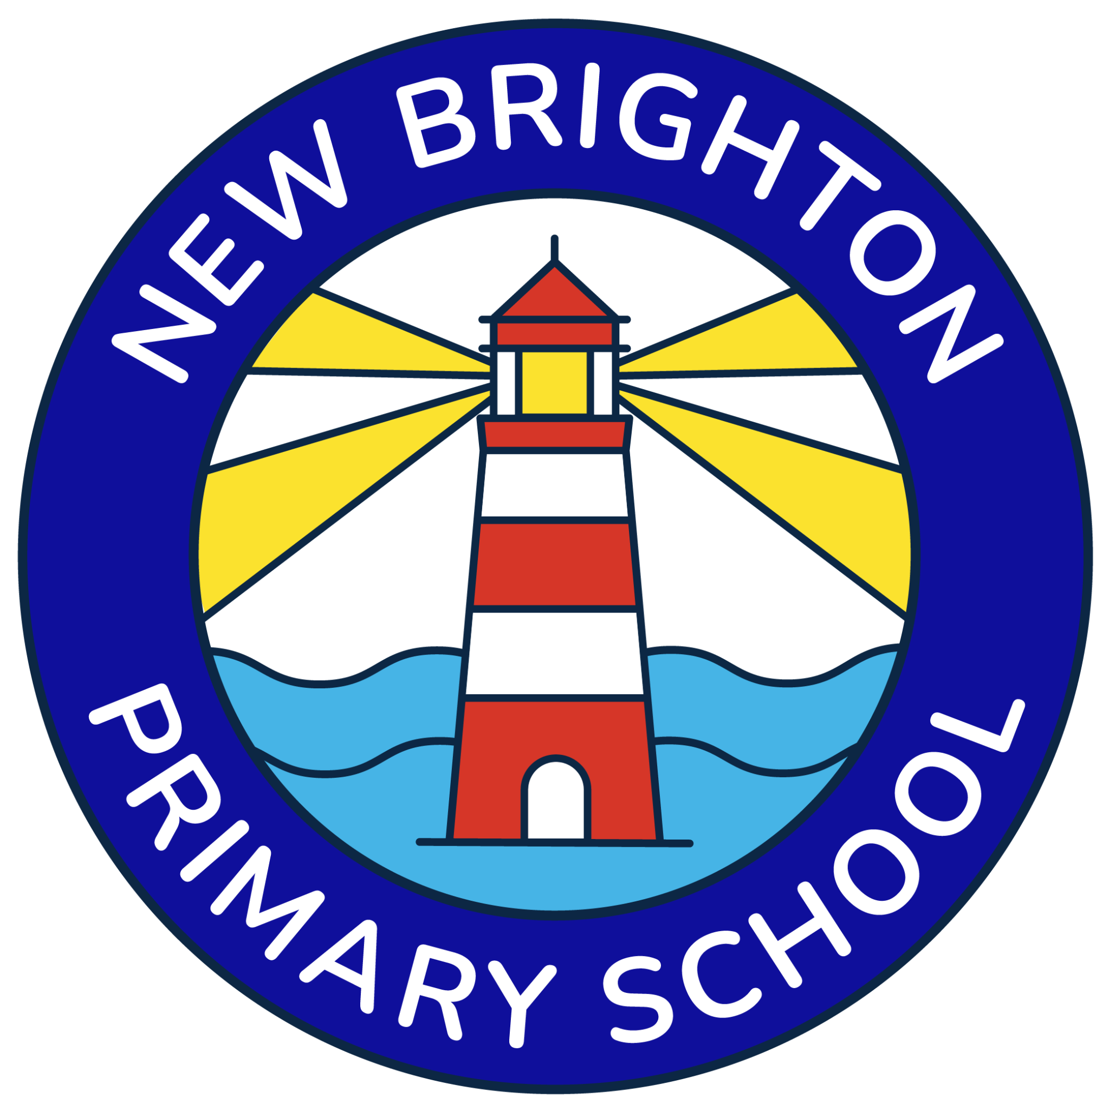 | NEW BRIGHTON PRIMARY SCHOOL  Administration Assistant  Vacancy

35 HOURS PER WEEK | TERM-TIME ONLY | WIRRAL

Hours | Monday-Friday, 8:30am-4:30pm (1 hour unpaid lunch) - 35 hours per week
Weeks | 39 weeks per year - term-time only
Grade | Wirral Band B, SCP 3 - FTE £25,614
Salary | Approx. £21,610 p.a. pro rata (under 5 years' service); enhanced term-time salary applies where 5+ years' service is recognised
New Brighton Primary School is looking to appoint a friendly, organised and highly efficient Administration Assistant to join our busy school office team.
This is a varied front-of-house and administrative role at the heart of school life. The successful candidate will be an important first point of contact for children, families, staff, visitors and professionals, while providing high-quality administrative support across the school.

We are looking for someone who:
- is warm, approachable and professional, with excellent communication and customer-service skills;
- is organised, accurate and able to manage a busy workload while meeting deadlines;
- has strong IT skills and is confident using email, word processing, spreadsheets and electronic record systems;
- can deal sensitively and calmly with pupils, parents and carers and understands confidentiality, safeguarding and data protection;
- works well as part of a team and takes pride in providing an efficient, welcoming school office service.

The role will include:
- reception, telephone and email duties;
- pupil administration, record keeping and attendance administration, including first-day calling;
- supporting trips, meetings, events, reports and general correspondence;
- supporting pupils who are unwell and administering medicines in line with school procedures;
- general administrative support for the Headteacher, Senior Leadership Team and staff.
We can offer: a welcoming and supportive school community, a varied role where no two days are quite the same, and the opportunity to make a real contribution to the smooth running of New Brighton Primary School.
Safeguarding
New Brighton Primary School is committed to safeguarding and promoting the welfare of children. The successful candidate will be subject to appropriate pre-employment checks, including an enhanced DBS check, satisfactory references and identity/right-to-work checks. References will be requested prior to interview in line with safer recruitment practice.
Visits to the school are warmly welcomed. Please contact the school office to arrange a visit or find out more about the role.
Please submit a completed application form. CVs alone will not be accepted.
Closing date | [insert date and time]
Interview date | [insert date]

