Job description
Job title | Educational Psychologist
Grade | Soulbury (A) Points 3-11  (Inclusive of 3 SPA points as applicable)  Scale subject to extension pending formal review.
Directorate | Children and Young People
Service/team | Inclusion Service
Accountable to | Principal Educational Psychologist
Responsible for | Opportunities for TEP supervision available
JE Reference |  | Date Reviewed | July 2026

Purpose of the Job

- To promote child development and learning through the application of psychology, by working with individual and groups of children, teachers and other adults in schools and families.
- To work with colleagues in other agencies to ensure effective delivery of service to children, young people, and their families
- To monitor and evaluate the outcomes in relation to children with additional needs.
- To undertake the five core functions of an Educational Psychologist; assessment, consultation, intervention, training and research within designated role.
- To support with the delivery of statutory and preventative work as needed within the Service Delivery Model and wider Experts at Hand offer.

Duties and Responsibilities

This is not a comprehensive list of all the tasks, which may be required of the post holder. It is illustrative of the general nature and level of responsibility of the work to be undertaken.

- To undertake a consultation approach with children and young people aged 0-25, their families and their schools, where there are concerns about development and/or progress.
- To undertake assessment and intervention work which may arise from the consultation approach.
- To contribute to statutory Education, Health and Care Needs Assessments and SEND (Special Educational Needs and Disabilities) reviews through provision of Psychological Advice in line with guidance in the SEND Code of Practice.
- To provide an Educational Psychology service to a group of identified schools.
- To provide professional advice and/or coaching on a range of strategies at an individual, group, or whole school level to empower staff and children in meeting additional needs.
- To work with parents/carers and their children in the early years, in conjunction with other agencies.
- Where appropriate, work with Social Care colleagues to apply psychology to those difficulties faced by children looked after and children with complex needs.
- To work collaboratively with other services, through efficient communication, sharing of information and joint planning.
- Where appropriate, contribute to other statutory work e.g. SEND Reviews, SEND Mediations and Tribunals.
- To monitor the outcomes of interventions for children, their families and the identified schools through the collection, collation, and reporting of accurate data - both quantitative and qualitative – related to interventions.
- To support with the delivery of the Experts at Hand Model in line with Knowsley’s Send Reform Plan and the core functions of EP practice.
- To undertake project work and research which contributes to the borough’s Children’s and Young People’s Plan and related departmental plans.
- To undertake professional development relevant to a Main Grade Educational Psychologist e.g. supervision of Trainee EPs.
- Where appropriate, to attend and contribute to the agenda of team meetings.
- To undertake additional duties at the request of the Principal Educational Psychologist.
- To uphold equal opportunities in employment, in advice and in service delivery.
- To comply with all the requirements of Health and Safety Legislation and Council Policy, taking appropriate action where necessary.
- To comply with all the Council’s Financial and Contract Procedure Rules.
- To carry out duties requested by the Executive Director Mark Mirfin commensurate with the grading of the post.

Knowsley Better Together – Staff Qualities

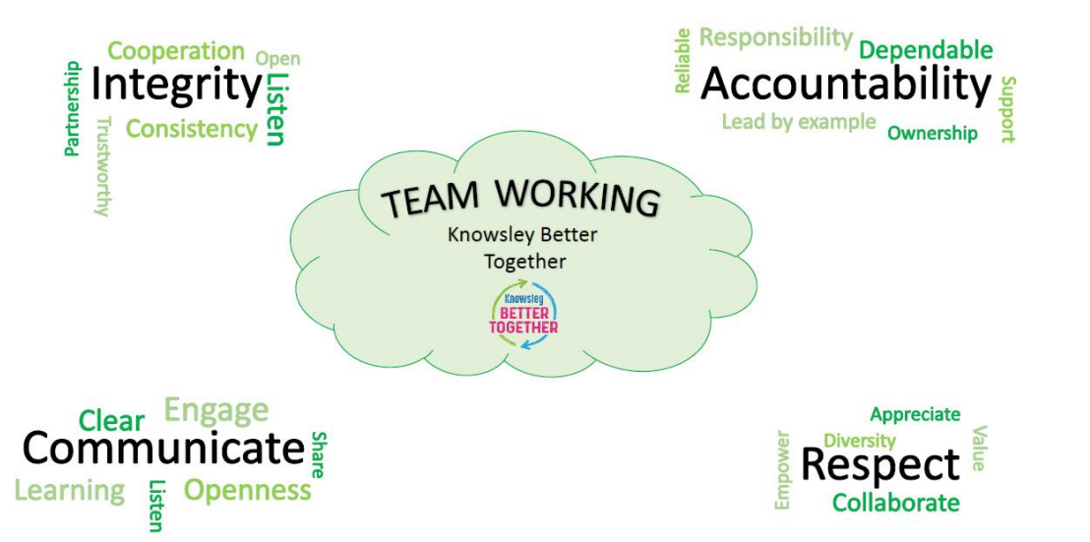

Health and Safety

- To use equipment as instructed and trained.

- To inform management of any health and safety issues which could place individuals at risk.

Data Protection and Information Security

- Implement and act in accordance with the Information Security Acceptable Use Policy, Data Protection Policy and GDPR.

- Protect the Council’s information assets from unauthorised access, disclosure, modification, destruction or interference.

- Report actual or potential security incidents.

