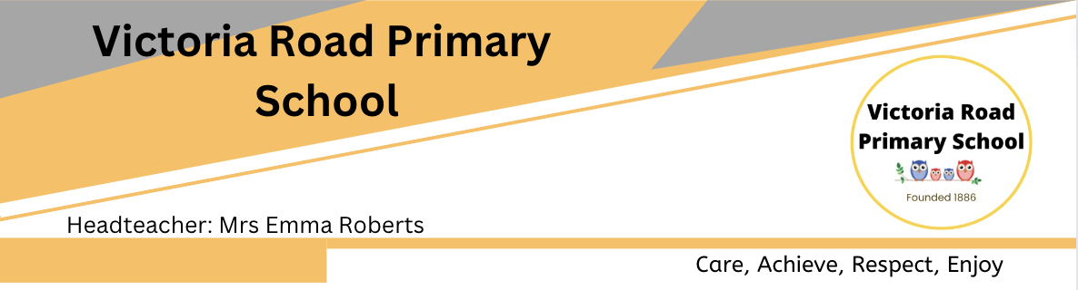
Job Description

Kitchen Porter
School: Victoria Road Primary School
Responsible to: Catering Manager / School Business Manager
Working Location: School Kitchen
Salary: HBC 02 SCP 3-4. FTE £24,796 to £25,185
Hours: 10
Contract: Fixed Term – 31/10/2029 or until contract with provider ends

Job Purpose
To support the day-to-day operation of the school kitchen by safely heating and serving pre-prepared school meals, maintaining high standards of cleanliness and hygiene, and ensuring the kitchen and dining areas are kept clean, tidy and safe.
The postholder will work as part of the school catering team to ensure that pupils receive their meals safely, efficiently and in a welcoming environment.

Key Responsibilities

Meal Service
- Receive and store pre-prepared meals and catering supplies in accordance with food safety requirements.
- Safely heat pre-prepared meals in accordance with the catering provider's instructions and school procedures.
- Check and monitor food temperatures as required and maintain appropriate records.
- Prepare the serving area and ensure meals are ready for service at the required times.
- Serve meals to pupils and staff in accordance with portion control requirements.
- Ensure that meals are provided in accordance with children's known dietary and allergen requirements.
- Follow all procedures relating to children with allergies and special dietary requirements.
- Replenish food and serving equipment during service as required.
- Provide a friendly and welcoming service to pupils.
- Ensure food service areas remain clean and tidy throughout the meal service.

Cleaning and Hygiene
- Clean and sanitise kitchen equipment, utensils, work surfaces and other areas as required.
- Wash and store crockery, cutlery, trays and catering equipment.
- Keep kitchen floors, work surfaces and other areas clean and tidy.
- Clean food service and dining areas as required.
- Empty bins and dispose of food and other waste appropriately.
- Follow all food hygiene, health and safety and cleaning procedures.
- Use cleaning products and equipment safely and in accordance with instructions.
- Report any spillages, hazards, damaged equipment or maintenance issues promptly.

Kitchen Support
- Assist with the receipt and storage of food deliveries.
- Check that food is stored appropriately and within required temperature conditions.
- Assist with stock rotation and monitoring of catering supplies.
- Ensure equipment and resources are kept clean and returned to their appropriate storage areas.
- Assist with setting up and closing down the kitchen each day.
- Maintain a high standard of personal hygiene and wear appropriate protective clothing.
- Support the catering operation in ensuring that all areas are maintained to a high standard.

General Duties
- Work cooperatively as part of the school catering team.
- Communicate appropriately and courteously with pupils, colleagues and visitors.
- Maintain confidentiality in relation to pupils and school matters.
- Comply with all school policies and procedures.
- Undertake relevant training as required.
- Promote the health, safety and wellbeing of pupils and colleagues.
- Carry out any other reasonable duties appropriate to the role.

Safeguarding
Victoria Road Primary School is committed to safeguarding and promoting the welfare of children and expects all staff and volunteers to share this commitment.
The successful applicant will be subject to the appropriate pre-employment safeguarding checks, including an enhanced DBS check, in accordance with the requirements of the role.

Person Specification

Kitchen Porter

Essential Criteria
Experience
- Experience of working in a kitchen, catering, cleaning or similar environment is desirable but not essential.
- Experience of working as part of a team.
- Experience of following instructions and agreed procedures.
Skills and Abilities
- Able to work efficiently in a busy environment.
- Able to maintain high standards of cleanliness and hygiene.
- Able to follow food safety, health and safety and safeguarding procedures.
- Able to follow written and verbal instructions accurately.
- Able to safely operate kitchen equipment following appropriate training.
- Able to communicate effectively and courteously with colleagues and pupils.
- Good attention to detail.
- Able to work independently and as part of a team.
Knowledge
- Basic understanding of food hygiene and safe working practices.
- Understanding of the importance of cleanliness within a food service environment.
- Awareness of the importance of following allergen and dietary requirement procedures.
Personal Qualities
- Reliable and punctual.
- Hardworking and willing to undertake practical tasks.
- Positive and friendly attitude.
- Flexible and willing to respond to the needs of the kitchen.
- Calm and professional when working under pressure.
- Respectful and courteous towards children, staff and visitors.
- Committed to maintaining high standards.
- Committed to safeguarding and promoting the welfare of children.

Desirable Criteria
- Level 2 Food Safety / Food Hygiene qualification.
- Previous experience of working within a school, nursery, catering or hospitality environment.
- Experience of serving food to children.
- Experience of working with pre-prepared or delivered meals.
- Knowledge of allergen awareness and special dietary requirements.
- Basic knowledge of COSHH and safe use of cleaning products.

Qualifications and Training
Essential
- Willingness to undertake food hygiene and other relevant training required for the role.
Desirable
- Level 2 Food Safety / Food Hygiene qualification.
- Relevant catering or hospitality qualification.

Safeguarding
The successful candidate will be expected to demonstrate a commitment to safeguarding and promoting the welfare of children.
Appointment will be subject to satisfactory references and all required pre-employment checks, including an enhanced DBS check.



