




Business Support Assistant
Applicant Recruitment Pack
Sefton is a really great place to live and work
PHOTO TO BE ADDED


Welcome
Hi,
We would like to thank you for your interest in the Business Support Assistant role within Sefton Council’s Sefton Arc service, supporting our Electrical and Alarms teams.
This is an exciting opportunity for someone who enjoys being organised, working as part of a busy team and providing high-quality administrative and customer-focused support.
You’ll play an important role in helping to keep our services running smoothly. From maintaining accurate customer records and updating systems and spreadsheets, to liaising with suppliers, supporting maintenance and service contracts, placing orders and providing general administrative assistance, you’ll help ensure that information is accurate, up to date and handled efficiently.
We’re looking for someone with excellent IT and communication skills, who can work confidently with colleagues, customers, suppliers and external organisations. You’ll need to be able to manage your workload effectively, follow instructions without constant supervision and approach your work with accuracy, professionalism and a positive, can-do attitude.
Just as importantly, we’re looking for someone who enjoys being part of a team. If you’re motivated, enthusiastic, approachable and take pride in providing a reliable service to others, you could be a great fit for the role. You’ll also understand the importance of confidentiality, data protection and working in line with relevant policies and procedures.
The Job Description and Person Specification for this role are included within the job pack and provide further information about the role, the skills and experience we’re looking for, and the requirements of the post. Please note that appointment will be subject to the required pre-employment checks, including vetting to BS7858 Standard.
If you have any questions about the vacancy, please refer to the job pack for the appropriate contact details.
If, when you’ve finished reading this pack, you like what you see and Sefton’s Vision and Values align with yours, then we can’t wait to hear from you.
Best of luck!
Jill Readfern MCIPD
Head of HR & Workforce

Contents
About the Borough of Sefton 1
Our Vision and Values 2
Our Successes and Key Projects 2
An Inclusive Workplace 3
Liverpool City Region Fair Employment Charter 4
What We Can Offer You 4
About the Role 6
Top Tips on How to Apply 8
Application and Selection Information 9
Appendix A – Job Description and Person Specification 10

About the Borough of Sefton

Sefton is a confident and well-connected Borough, stretching from Bootle in the south to the coastal resort of Southport in the north. Home to more than 275,000 residents, Sefton encompasses a range of vibrant towns and communities, including Bootle, Litherland, Seaforth, Crosby, Formby, Maghull and Southport.
It is a fantastic place to live and work. As the northern-most Borough within the Liverpool City Region, Sefton offers a unique blend of beautiful coastline, countryside, attractive villages, thriving industrial areas and the busy Port of Liverpool.
With 22 miles of stunning coastline, Sefton is a leading coastal destination with a growing visitor economy. It is home to the iconic Antony Gormley Another Place installation, expansive beaches and protected sand dunes that support several rare species.
While each town and village has its own distinctive character, it is the people of Sefton who make the Borough truly special, creating diverse, welcoming and energetic communities in which to live, work, invest and visit.
Alongside its miles of golden sands, Sefton offers those who work here access to a world-renowned racecourse, prestigious golf courses, and National Trust nature reserves, ideal places to unwind, explore and enjoy leisure time.
The Borough benefits from excellent transport links, providing easy access to major North West cities including Liverpool and Manchester, and placing the Lake District and North Wales within reach for weekend breaks.
Whether you prefer vibrant town centres, friendly commuter towns, picturesque villages or stunning rural and coastal locations, Sefton offers a place to suit everyone. With house prices and rents typically lower than in neighbouring Liverpool and Manchester, you can enjoy coastal living while still being close to the buzz of city life.

Our Vision and Values

At Sefton Council, our vision is to deliver high-quality services that make a real difference to the lives of our residents, visitors, and communities. Everything we do is guided by a strong set of values that shape how we work and interact:

- We put people at the heart of what we do – ensuring our services are responsive, inclusive, and focused on improving lives.
- We listen, value, and respect each other’s views – fostering a culture of collaboration and mutual respect.
- We develop a culture of challenge, ownership, innovation, and improvement – encouraging creativity and continuous development.
- We are ambassadors for Sefton – promoting the Borough positively and proudly representing our communities.
- We are responsive and efficient – delivering services that are timely, effective, and customer-focused.
- We are clear about what we can and cannot do – being transparent and honest in all our communications and actions.
These values underpin our commitment to excellence, inclusivity, and innovation, ensuring that Sefton remains a great place to live, work, and visit.

Our Successes and Key Projects

Sefton Council is proud of its recent achievements and ongoing commitment to delivering high-quality services. Our Adult Social Care services were recently graded Good by the Care Quality Commission (CQC), and our Children’s Services also achieved a Good rating from Ofsted. These successes reflect the dedication and professionalism of our teams and our focus on continuous improvement.

More recently, we are exceptionally proud to have been nominated and subsequently shortlisted by the Local Government Chronicle for the Most Improved Council 2026. These successes reflect the dedication and professionalism of our teams and our focus on continuous improvement and our desire to make a difference across the communities within the Borough of Sefton.
Alongside these achievements, Sefton Council is actively delivering a range of major capital projects that will transform the Borough and stimulate economic growth. These include the Marine Lake Events Centre in Southport, the Strand Shopping Centre redevelopment in Bootle, and exciting developments such as the Cove Resort and Enterprise Arcade in Southport. We are also proud to support cultural and community initiatives like Salt and Tar, Bootle’s vibrant events space, which hosts live music, comedy, and family-friendly activities, bringing people together and boosting the local economy.

These projects form part of our strategic investment programme to attract private sector-led development and create vibrant spaces for residents and visitors. We work closely with local communities to ensure these projects reflect their needs and foster a sense of ownership and pride.
For more information on these projects and to stay updated on progress, visit the Sefton Council website at www.sefton.gov.uk

An Inclusive Workplace

We are committed to fostering an inclusive Council that reflects the diverse communities we serve. Our workforce brings a wide range of experiences and perspectives, and we value an environment where everyone feels respected, supported, and able to reach their full potential.

Sefton is proud to be the first local authority in the Liverpool City Region to achieve Navajo accreditation, recognising our commitment to LGBTQ+ inclusion. We are also a Disability Confident employer and continue to build a workforce that represents our communities.
We support several staff networks, including groups for Black and Ethnically Diverse colleagues, LGBTQ+ staff, women, disabled employees, and a Christian Workplace Group.

As an Equal Opportunities Employer, we base recruitment solely on skills, experience, and suitability for the role. All applicants are treated fairly, and we have also recognised ‘care experienced’ as a protected characteristic within Sefton.

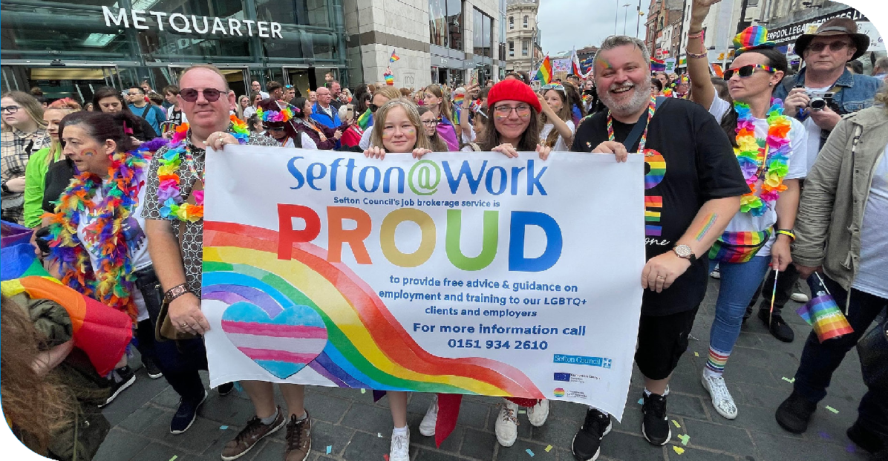

For more information, please refer to our Equality, Diversity and Inclusion Strategy

Liverpool City Region Fair Employment Charter


Sefton Council is proud to support the Liverpool City Region Combined Authority Fair Employment Charter, an initiative that promotes fair, healthy, inclusive, and just workplaces across the region. The Charter celebrates good employers and encourages the highest standards in employment practice, including fair pay, secure work, opportunities for progression, strong employee voice, and a commitment to staff wellbeing. By aligning with the Charter, we demonstrate our dedication to providing a fair day’s pay for a fair day’s work and to fostering an equitable and supportive working environment for all colleagues.

What We Can Offer You

- A supportive and collaborative working environment.
- An agile approach to working.
- Opportunities for professional development and career progression.
- A role where your work makes a real difference across the organisation.
- Flexible working arrangements supporting work-life balance.
- A strong commitment to equality, diversity, and inclusion.
You will benefit from a comprehensive local government employment package which includes the following:
- Competitive salary in line with NJC Local Government Pay Scales.
- Membership of the Local Government Pension Scheme (LGPS), providing a secure, defined benefit pension with employer contributions.
Annual Leave and Work-Life Balance
- Generous annual leave entitlement, 28 days annual leave rising to 33 days with 5 years continuous service.
- Additional public (bank) holidays.
- Flexible working options to support a healthy work-life balance, subject to service needs.
- Option to purchase additional annual leave.
- Sefton operate a ‘Shut Down’ period over the Christmas period which staff contribute four fifths of a week’s pay over a 12-month period.
Learning, Development and Career Progression
- A comprehensive induction programme.
- Access to a wide range of training, apprenticeships, learning, and development opportunities.
- Support for professional development and role related qualifications.
- Opportunities to develop your career within a large and diverse local authority.
Health, Wellbeing and Support
- Enhanced sick pay scheme.
- Employee wellbeing initiatives and access to occupational health support.
- Policies that promote physical and mental wellbeing in the workplace.

Family-Friendly and Inclusive Policies
Our family-friendly policies and flexible working arrangements help staff maintain a healthy work-life balance.

- Family friendly policies, including enhanced maternity, paternity, adoption, neonatal care and special leave to support with time off work to deal with issues when life events happen.

- A strong organisational commitment to equality, diversity, and inclusion.
- Reasonable adjustments and support to enable disabled employees to thrive.
Foster Friendly Employer Commitment
Sefton Council is proud to be a Foster Friendly organisation as recognised by The Fostering Network. We actively support employees who are foster carers or who are applying to foster by offering flexible working arrangements, paid time off for fostering-related meetings and training, and a workplace culture that recognises the vital role foster carers play in our communities.
This commitment helps ensure carers can balance fostering responsibilities alongside career, and reflects our dedication to supporting children, families, and those who care for them.

Additional Benefits
- Access to salary sacrifice and employee benefit schemes (where applicable).
- Opportunities to contribute to meaningful work that supports local communities.
- A supportive, values led organisational culture.
- Free parking at office bases (dependent upon the work location).

We are an Equal Opportunities Employer; all candidates will receive equal treatment. Our decision to appoint will be based upon whether an individual’s skills, experience, qualifications, and abilities make them the most suitable candidate for the role.
All disabled and care experienced applicants will be offered an interview where they meet all essential criteria on the person specification.
Please ensure that you meet all the essential criteria outlined in the person specification before submitting your application. Only applicants who demonstrate that they meet all essential criteria will be considered and invited to interview.

Appendix A – Job Description and Person Specification

Post Title: Business Support Assistant

Department: Operational In-house Services

Division: Sefton Arc

Post Grade: Grade D

Location: 209 Linacre Lane

Post Hours: 36

Responsible to: Senior Alarms & Electrician Officer

JOB PURPOSE

To provide clerical, administrative support to the electrical and alarm service under the direction/instruction of senior staff to meet accreditation requirements.

SUMMARY OF MAIN DUTIES

- Assist in maintaining and updating a computerised customer access data base.

- Liaise with suppliers to ensure timely delivery and service performance.

- Undertake ICT based tasks including reports, schedules, uploading information and data inputting onto customer records etc.

- Prepare and action maintenance/service contracts for new and existing customers

- Provide general administrative assistance to the Alarm and Electrical services.

- To arrange ordering and secure storage of supplies for the Electrical and Alarms services.

- Support a value for money approach with suppliers following the correct procurement route.

- Comply with policies and procedures including health and safety, confidentiality and data protection, escalating all concerns to an appropriate person.

- Contribute to the aims and development of the electrical & alarms services.

- To be a team player, appreciating and supporting the role of colleagues within the team.

- Ensuring all electronic paperwork, systems & spreadsheets are completed accurately, kept up to date & stored in a correct manner.

GENERAL

- The post holder will be expected to work flexibly, Other reasonably similar duties may be allocated from time to time commensurate with the general character of the post and its grading to meet the needs of the service.

- The post holder will be required to undertake, and participate in training, coaching and development activities, as appropriate.

- All staff are responsible for the implementation of the Health & Safety Policy as far as it affects them, colleagues and others who may be affected by their work. The post holder is also expected to monitor the effectiveness of the health and safety arrangements and systems to ensure appropriate improvements are made where necessary.

- The Authority has an approved equality and diversity policy, and copies are available to all employees via the intranet. The post holder will be expected to comply, observe and promote the equality and diversity policies of the Council.

- Since confidential information is involved within the duties of this post, the post holder will be required to always exercise discretion and to observe relevant codes of practice and legislation in relation to GDPR.

Prepared by: Name Joanne Alty

Designation Service Manager

Date May 2025
PERSON SPECIFICATION

POST Administration Clerk GRADE D

DEPARTMENT Operational In-House Services SECTION Sefton Arc

Personal Attributes Required | Essential € or  Desirable (D) | Method of Assessment
Qualifications/Training
- NVQ Level 2 in numeracy/Maths and literacy/English  - NVQ Level2 in business administration/customer service or equivalent qualification or experience | D  D | AF/C  AF/C
Experience
- Previous experience of clerical/administrative work. | E | AF/I

Ability, Skills & Knowledge
- Knowledge of service-related Health & Safety Regulations e.g. Alarms, Emergency Lighting, Fire Extinguisher.  - Excellent IT skills and working knowledge of Microsoft Word and Excel for data recording, analysis, and reporting.  - Knowledge of customer care understanding of the impact of service delivery for customers.  - Willingness to carry out instructions without constant supervision.  - Be able to meet customer needs.  - Ability to work with staff and external agencies both face-to-face and over the telephone.  - Excellent interpersonal skills with the ability to communicate effectively both written and orally at all levels within the organisation and with external bodies. | D  E  D  E  E  E  E | AF/I  AF/I  AF/I  AF/I  AF/I  AF/I  AF/I
Personal Style and Behaviour
- A passion for translating data into useful insight.  - Motivated, optimistic, and enthusiastic with the ability to respond to challenge and not be discouraged.  - An inclusive team worker, able to work with others and in a collaborative manner. | E  E  E | AF/I  AF/I  AF/I
Other/Special Requirements
- Must have a 5-year checkable work/school record.  - Acceptance for the post will depend upon the successful completion of vetting to BS7858 Standard. | E  E | AF/I  AF/C

AF=application form C=certificate I=interview

