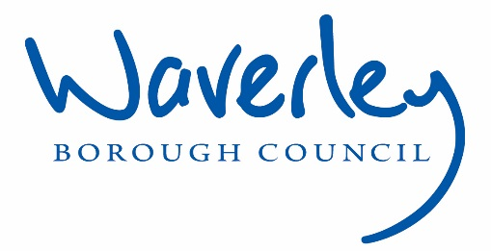

Waverley is an ambitious authority, committed to being one of the leading Councils in the country at a time of major change by developing a high performing, highly engaged staff team to share the organisation’s values and deliver our corporate objectives.
Job Description
Job title: | Attraction and Resourcing Manager
Service: | Democracy, Law & People
Team: | People & OD
Location: | The Burys, Godalming, Surrey, GU7 1HR and,  Millmead House, Guildford, Surrey, GU2 4BB
Reporting to: | Head of People Operations
Responsible for:  Banding: | Resourcing Officer and x3 People Administrators
Our Organisational Values
  Collaboration | We know, work with and support one another. We collaborate with residents, businesses and partners and realise the potential of the Guildford and Waverley Collaboration. We empower ourselves and others.
  Wellbeing | We look after our own and other’s wellbeing. We know it’s okay to talk to each other about anything we are struggling with. We stay resilient and raise any concerns we have.
Trusted   | We abide by the Nolan Principles of Public Life: Selflessness, Integrity, Objectivity, Accountability, Openness, Honesty, and Leadership.
Value for Money   | We spend public money wisely and carefully. We understand and follow our governance processes and raise any concerns with the right person. We celebrate successes and learn from mistakes.
Professionalism   | We provide professional advice and excellent service, we know our local areas and understand the communities we serve. We listen to all concerns and ideas. We benchmark our performance and always strive to improve.
Principal purpose of the role
- To lead the design and delivery of inclusive, efficient and candidate-friendly attraction, resourcing and people administration services across Guildford and Waverley Borough Councils.
- The postholder will shape the councils’ approach to employer branding, resourcing campaigns, candidate and employee experience, recruitment and employment compliance, ensuring a seamless end to end service from attraction to appointment to ongoing people administration.
- The postholder will also ensure the effective use of digital platforms and systems across recruitment and people administration, supporting line managers through change and challenge, and play a key role in workforce planning, talent pipelines and internal progression strategies.
- The postholder leads the strategic development of the recruitment and people administration function, line managing the Resourcing Officer and People Administration team, ensuring effective service delivery,statutory compliance and continuous improvement aligned with organisational priorities.
- To maintain strategic oversight on temporary staffing usage and spend across both councils with detailed plans to convert to permanent roles or FTC where appropriate.
- The postholder will play a key role in helping to shape attraction and resourcing approaches as the councils transition into the new West Surrey authority
Main duties and accountabilities
Attraction Strategy
- Develop and deliver recruitment strategies to position both councils as inclusive, modern and purposeful employers.
- Oversee the production of recruitment materials, social media campaigns, microsites and candidate packs that reflect the councils’ values and culture.
- Use external and internal feedback to continuously refine the candidate journey and early employee experience and value proposition.
- Promote council career opportunities through outreach, events, partnerships, and community engagement. For example, careers fairs at schools, colleges and universities.
End-to-End Resourcing Delivery
- Oversee the full recruitment lifecycle from vacancy authorisation to onboarding and handover into people administration, ensuring a seamless transition from candidate to employee.
- Lead and deliver complex, strategic and senior-level recruitment campaigns, providing expert advice and support to senior managers and leadership teams.
- Support and coach managers on recruitment planning, panel selection, advert wording and interview design.
- Lead the coordination and quality assurance of interviews, assessments and onboarding processes, leading the people administration team to ensure accurate contracys, checks and timely start dates.
Systems & Process Improvement
- Act as system owner for the Applicant Tracking System (ATS) and work closely with the HR Systems and Data Manager on key people administration systems, ensuring effective configuration, data integrity and user adoption.
- Improve automation of candidate communications, starter processes and people administration workflows, reducing duplication and manual intervention.
- Ensure all resourcing and people administration activity is logged, tracked and monitored for compliance and reporting.
- Develop and maintain standard operating procedures (SOPs) for recruitment and people administration activity.
Inclusion, Accessibility & Policy
- Ensure all recruitment practices and people administration processes are inclusive and accessible, supporting the councils' EDI ambitions.
- Lead on the use of anonymised recruitment, flexible assessments, and reasonable adjustments in campaigns and ensure these are carried through into employment processes.
- Review and update recruitment and selection policy, alongside related people administration policies and procedures, ensuring legal compliance and good practice.
- Promote the councils’ employer commitments such as Disability Confident, Armed Forces Covenant and apprenticeships.
Talent Pipelines & Workforce Planning
- Work with People and OD Business Partners to identify future skill needs and hard-to-fill roles across the councils.
- Design talent pipeline approaches including apprenticeships, graduates, returners and redeployment.
- Support internal mobility and succession planning through secondments and development opportunities.
- Monitor market and demographic trends to adapt attraction approaches.
Team & Stakeholder Management
- Provide leadership, supervision and development to the Resourcing Officer and the People Administration team, managing capabity, performance and service standards
- Coordinate workload across recruitment and people administration to ensure timely, accurate and customer focused service delivery.
- Deliver training and guidance to hiring managers on recruitment best practice and employment administration processes.
- Monitor KPIs (e.g. time to hire, diversity of applicants, candidate satisfaction, starter accuracy and processing times) and report trends and improvements to the Head of People Operations.
- Build strong relationships with communications, hiring managers, payroll, People and OD business partners, HR systems and data team, external vendors, and partner organisations.

Dimensions of the role
This role leads all recruitment, attraction and people administration activity across both councils, overseeing end-to-end resourcing campaigns and employee administration services. It supports managers with complex hiring matters, and ensures systems, processes and service delivery are inclusive, efficient and legally compliant. The postholder leads continuous improvements across recruitment and people administration, strengthening candidate and employee experience, internal mobility, talent pipelines, and the councils’ external reputation as employers. The post line manages the Resourcing Officer and the People Administration team,working closely with internal and external partners to deliver effective, joined up people services.
Customers and Contacts
Internal
- Head of People Operations
- Hiring managers, assistant directors
- People & OD colleagues
- Communications and Branding
- Executive support (for senior level campaigns)

External
- Job board and social media partners
- Apprenticeship and graduate programme providers
- Recruitment search agencies
- Community organisations, schools, colleges and universities
- Accessibility and inclusion partners (e.g. disability confident)

Additional Notes:
- All work performed and duties undertaken must be carried out in accordance with relevant Council and Service policies and procedures, within legislation and with regard to the needs of our customers and diverse communities we serve.
- This document sets out the main dimensions of the job it describes. It does not define all individual tasks, which may be expected to change from time to time to meet operational needs.
- You will be expected to be flexible in your duties and carry out any duties commensurate with the grade and falling within the general scope of the job, as requested by your line manager.
Health and Safety / Risk Management
- Ensure that all aspects of the Councils’ Health and Safety Policies and Procedures are adhered to.
- Be responsible for identifying and managing all risks associated with the job role through effective application of internal controls and risk assessments to support the achievement of corporate and service objectives.
- Adhere to the relevant Councils’ constitution.
- Champion Safeguarding policy and practice.
Service/Team Structure
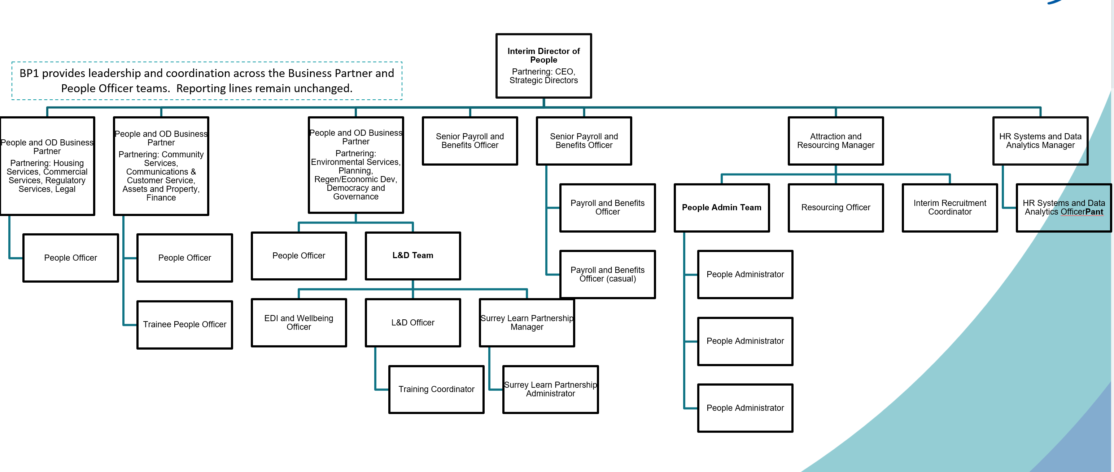
PERSON SPECIFICATION

Candidates must be able to demonstrate, giving examples, all essential criteria marked as A, A/C or A/I within their application form to be shortlisted for this role.

 | Person Specification
 | Essential criteria | How Assessed | Desirable criteria | How Assessed
Qualifications/ Education / Training / Experience | Significant experience leading recruitment activity within a complex organisational change or service redesign environment | A / I | Experience in local government or shared services | A / I
Qualifications/ Education / Training / Experience | Experience managing and developing employees | A / I | Recruitment qualification | A
 | Track record of designing and implementing recruitment and retention strategies | A / I | CIPD level 7, or working towards | A
Knowledge / Skills | Expert knowledge of employment law and recruitment legislation and inclusive recruitment best practice | A / I
 | Understanding of workforce planning, talent pipelines and succession planning | A / I
 | Proficient in using and managing applicant tracking systems (ATS) and integrations with HRIS | A
 | Project and change management skills to deliver service improvements | A / I
Communication | Ability to build credibility and influence with senior leaders, directors and elected members | A / I
 | Ability to communicate complex information clearly | A / I
 | Ability to work under pressure and to tight deadlines | A / I
Customer service | Ensures managers receive professional, high quality recruitment support | A / I
 | Focuses on delivering a positive candidate experience throughout the recruitment process | A / I
 | Builds strong relationships with external partners (universities, agencies, networks) | A / I
Managing self and others | Line manages the resourcing officer and people admin team and provides coaching/mentoring
 | Oversees workload allocation and ensure service standards are met
 | Ability to coach and influence hiring managers
Can do approach / achieving results | Use workforce data and intelligence to inform attraction strategies and identify future workforce risks
 | Improves efficiency, candidate experience and recruitment outcomes
 | Able to work at pace, while managing a complex workload and maintaining your own resilience
 | High attention to detail and organisational ability
ADDITIONAL SPECIFIC REQUIREMENTS FOR THIS POST*

* Please note that Waverley Borough Council cannot guarantee to supply you with the provision of equipment such as laptop, tablet, mobile phone or pool vehicle

How assessed:

A = Application CV/Personal Statement
C = Certificates/professional Registration
D = DBS police check
E = Exercise
I = Interview
M = Medical assessment

For Official Use only
Job title: | Attraction and Resourcing Manager | Post no:
Service: | Democracy, Law & People | JE score:
Team: | People & OD | Pay band:
Location: | The Burys  Godalming,  Surrey GU7 1HR  And  Millmead House  Guildford  Surrey GU2 4BB | Position type:  (if part time, working pattern) | Full time  37 Hours/ Five day week
Competencies:  (level 1 – 4) | Communication: | Level 3
Competencies:  (level 1 – 4) | Customer Service: | Level 3
Competencies:  (level 1 – 4) | Team Working: | Level 3
Competencies:  (level 1 – 4) | Managing Self and Others: | Level 3
Competencies:  (level 1 – 4) | Can do approach/Results: | Level 3
Reviewed By: |  | Date:
Checked in: |  | Date:
Last Updated: | Clare Garcia | Date: | October 2026

