Online DBS Application Guidance for Applicant
To complete your DBS check online follow the guidance below:
- Go to https://www.dbsassist.co.uk/wirral
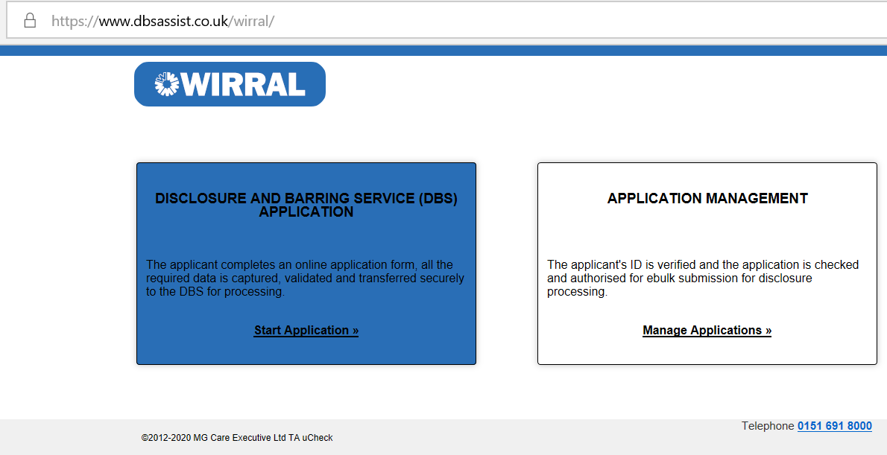
- Click on DBS Application Form - "Start Application" and the following screen will appear.
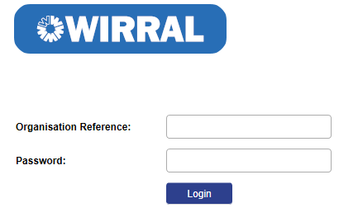
- Enter Organisation reference – CHILDREN (Capital Letters)
- Enter Password - wirral
(This password will be used each time you log into "Start Application").
- Click "Login"
- The blank application will then appear.

- Complete the application, with your details making sure all the mandatory fields (those with a * and in blue). You will not be able to proceed until these fields are completed. Use the notes on the right-hand side of the screen for guidance.
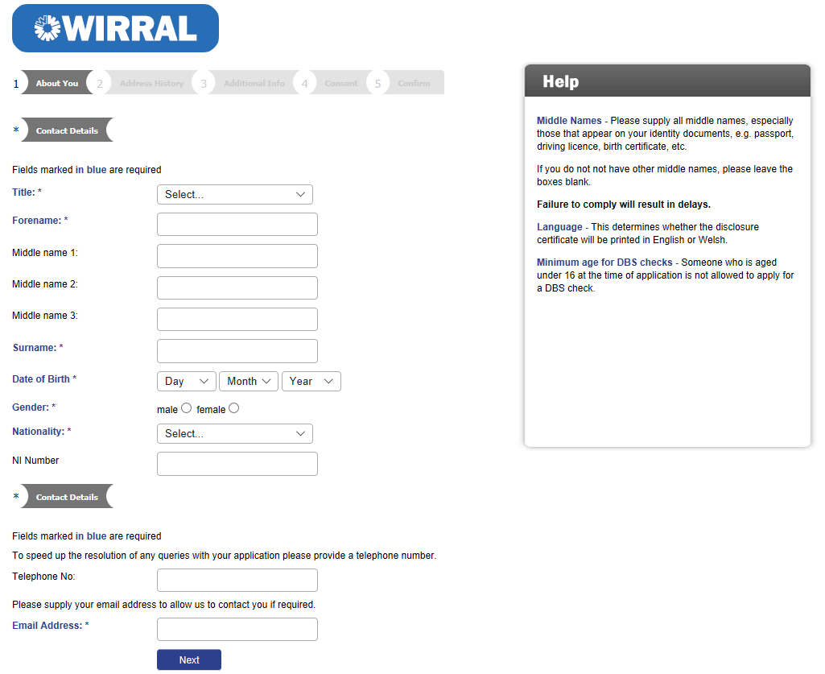
- Click Add Address Details, and enter address history for the past 5 years, which can be multiple addresses.
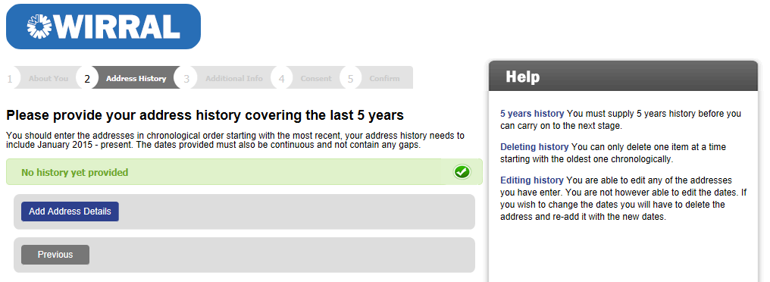
- Ensure that you leave the appropriate space in the postcode. It will let you proceed but will result in a ‘rejected application’ after submission. The error will have to be fixed by the administrators and resubmitted.
- Once you have more than 5 years or address history you can click “Next”.

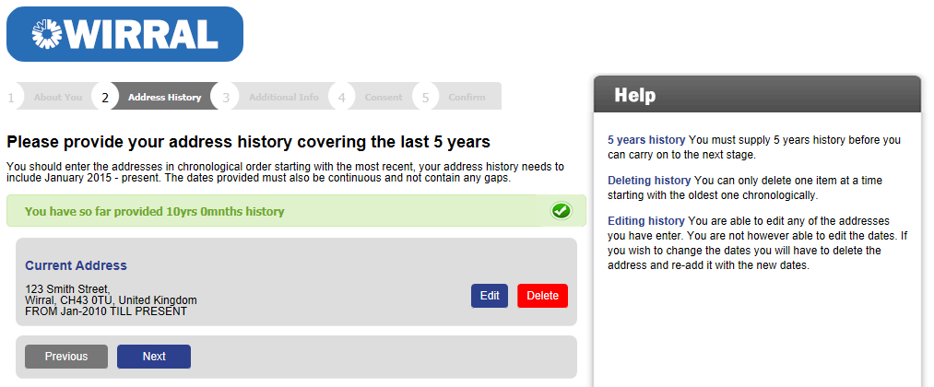

- Additional Info – If you have any previous names, update the Other Names section, if not, leave this blank.
- Place of Birth details and Conviction History are Mandatory fields and need to be completed.
- Once these details are all entered, click “Next”.
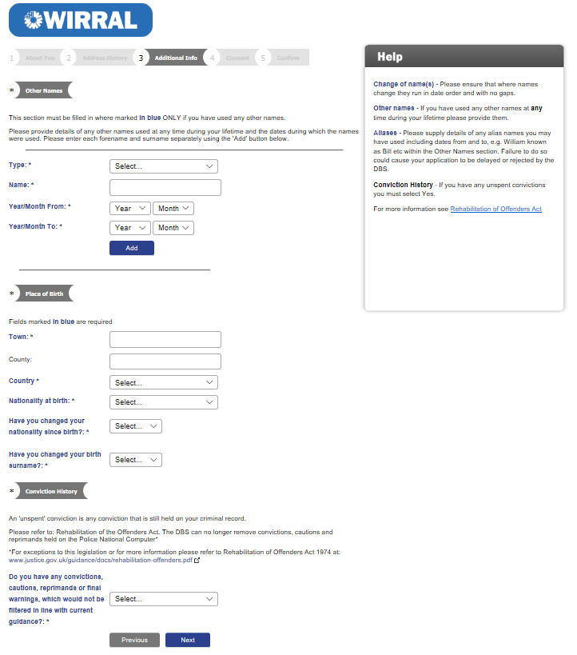

- You now need to read the Applicant Consent page and tick the 3 boxes at the bottom of the page to state you have read the information and agree.
- You also need to enter your Forename and Surname into the box provided before you can click “Sign and Continue”.
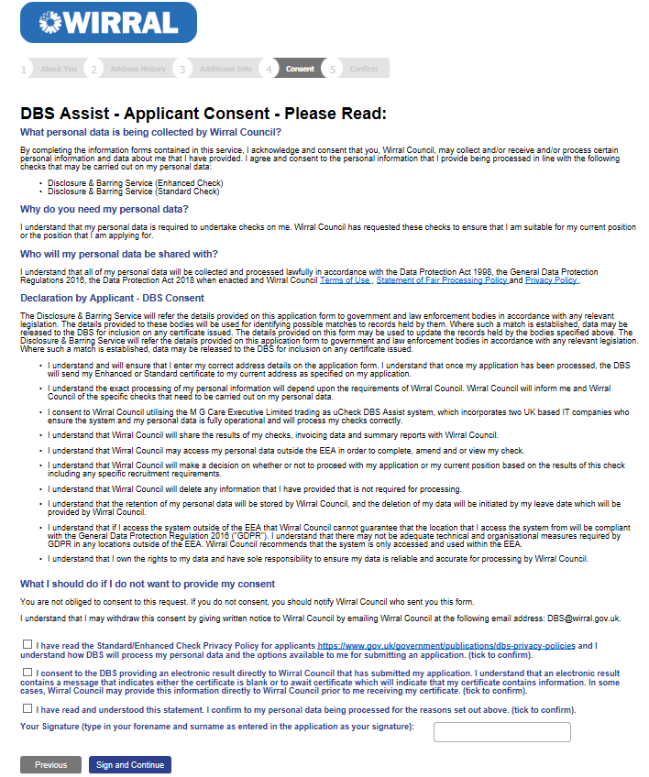

- You will then be provided with an overview of the information you have completed. If everything is correct, Click in the box to indicate consent and Click on "Submit"
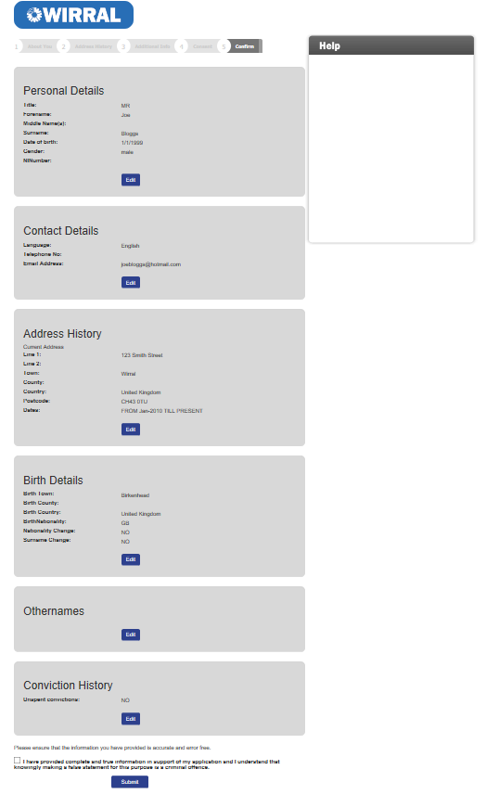
- Make a note of the unique form reference number
- Your DBS application has now been submitted. Please liaise with the relevant service to arrange for your Identification checks to be completed, if these haven’t been checked and recorded already.

Document Ownership
Document owned by: | Head of Human Resources / DBS Lead Signatory
Document written by: | Mike Wallace, Business Change Analyst / Andrea Morrell-Foulkes, Senior HR Officer/Team Leader, Change & Organisational Design
Date document written: | 15th January 2020
Policy due for 1st review: | 2023

Version Control Table
All changes to this document are recorded in this table.
Date | Notes/Amendments | Officer | Next Scheduled Review Date
February 2020 | - Version specifically for LEISURE organisation | Andrea Morrell-Foulkes, Senior HR Officer/Team Leader, Change & Organisational Design | 2023

